

**Capstone Project Phase B**

**OptiVision:**

**Advanced Screening for Early Detection of Eye Health Issues**

**24-2-D-23**

Tameer Amer 322836388

Redan Ganim 209003474

Mentor: Dr. Natali Levi

**Abstract**

OptiVision is a web application designed to provide accessible and user-friendly tools for the early detection of vision impairments. With millions of people worldwide affected by undiagnosed vision issues, there is a pressing need for a solution that allows users to conduct preliminary vision tests from the comfort of their homes. OptiVision addresses this need by incorporating a series of scientifically validated tests, including visual acuity, color vision, contrast sensitivity, blur detection, and field of vision assessments.

The application guides users through these tests, ensuring accurate results through an initial screen calibration process. Test results are securely stored in a database, allowing users to track their vision health over time. The system provides clear and actionable recommendations based on the results, encouraging users to seek professional eye care when necessary.

OptiVision operates by utilizing hardware inputs such as the user's monitor, mouse, and keyboard. The user first performs a screen calibration to ensure test accuracy, followed by a guided sequence of vision tests. Each test is interactive and tailored to measure specific aspects of vision health. After completing the tests, the system processes the data and displays a detailed report, highlighting any areas of concern. Users can revisit past results and monitor changes in their vision, allowing for early detection of potential issues. By making vision health assessments more accessible, OptiVision aims to reduce the number of undiagnosed cases and promote early intervention, ultimately improving the quality of life for individuals with potential vision impairments.

**Table Of Contents**

Contents

1.Introduction 6

1.1 Problem 6

1.2 Available Solutions 7

1.3 Our Solution 8

1.4 Beneficiaries 8

2. Background 8

2.1 Symptom Detection 8

2.1.1 Visual Acuity 9

2.1.2 Color Vision: 9

2.1.3 Contrast Vision 9

2.1.4 Blur Check 9

2.1.5 Watch the Dot Test 10

2.1.6 Environmental Factors 10

2.1.7 Eye Movement and Tracking 10

2.2 Gender Differences 11

2.3 Treatment 11

2.3.1 Corrective Lenses 11

2.3.2 Behavioral Adjustments 11

2.4 Risks 12

2.4.1 Risks of Symptom Detection 12

2.4.2 Risks of Symptom Development 12

3. Technologies 12

3.1 Programming Languages 13

3.2 Frameworks 13

3.3 Libraries and Tools 14

3.4 Calibration Tools 15

3.5 Key Features 15

3.6 Database and Hosting 16

3.7 Frontend and Deployment 16

4. Architecture Overview 16

4.1 How Our Database is Built 20

5. Activity Diagram: 21

Login Process: 21

Register Process: 22

Visual Acuity Test Process: 23

Color Vision Test Process: 24

Contrast Vision Test Process: 26

Blur Check Process: 27

Watch The Dot Test Process: 28

6. Project Work Division 29

Phase 1: Backend Development 30

Phase 2: Frontend Development 30

Phase 3: Testing and Validation 31

Phase 4: Deployment 31

Phase 5: Report Generation and Finalization 32

7. Challenges 32

8. Interface with the Client Throughout Development 35

9. User Experimentation and Testing Methodology 37

1. Navigation Test 37

2. User Authentication Testing 38

3. Test Filtering and Reporting Validation 38

4. Private Routes and Security Testing 39

5. Calibration Module Testing 39

6. Multi-Browser and Device Testing 40

10. Experiment and Evaluation 40

10.1 Experiment 40

10.2 Verification and Evaluation 41

10.2.1 Functional Testing 42

10.2.2 Acceptance Testing 43

10.3 Key Acceptance Test Results 43

10.4 Areas for Improvement 44

11. References 44

11.1 GitHub Link: 44

11.2 Academic References: 44

User Documentation 46

Developer Documentation 76

# 1.Introduction

## 1.1 Problem

The problem we aim to solve is the widespread issue of undiagnosed vision impairment. Vision impairment affects over 2.2 billion people globally, with at least 1 billion of these cases being preventable or yet to be addressed. The leading causes include refractive errors and cataracts, both of which are treatable conditions that, if left unaddressed, significantly impact individuals' quality of life, educational and employment opportunities, and overall well-being. The economic burden of untreated vision impairment is substantial, costing the global economy an estimated $411 billion annually​ [1][2]​.

Globally, at least 2.2 billion people suffer from near or distance vision impairment. In nearly half of these cases, the impairment could have been prevented or has yet to be addressed. The primary conditions contributing to distance vision impairment or blindness include cataracts (94 million), refractive errors (88.4 million), age-related macular degeneration (8 million), glaucoma (7.7 million), and diabetic retinopathy (3.9 million)​ [2]. Visual impairment, defined as the limited functional ability of an individual's vision system, prevents individuals from performing daily activities and cannot be fully corrected by conventional means.

According to the World Health Organization (WHO), as of 2014, there were approximately 285 million visually impaired people worldwide, with 39 million being blind and 246 million suffering from low vision. Additionally, 82% of those who are blind are aged 50 and older. With an aging population, the number of people at risk for visual impairment due to age-related eye diseases is expected to increase​ ​.

Currently, the primary solutions for diagnosing and treating vision impairment involve regular eye exams conducted by ophthalmologists or optometrists. These exams are crucial for detecting common eye conditions like myopia, hyperopia, astigmatism, cataracts, glaucoma, and diabetic retinopathy. Despite the availability of these services, many barriers prevent people from accessing them. These barriers include high costs, lack of awareness, inadequate health insurance, limited availability of eye care professionals, especially in low-income and rural areas, and logistical challenges such as transportation​ [3] ​.

## 1.2 Available Solutions

Currently, there are several methods to detect early signs of vision impairments, most of which require the involvement of a licensed professional or specialized equipment. One common approach is a comprehensive eye examination conducted by an optometrist or ophthalmologist. During these exams, the patient undergoes a series of tests that assess visual acuity, depth perception, color vision, and other critical aspects of eye health. Another solution involves using standard vision tests, such as the Snellen chart, which provides a general assessment of visual clarity but may not detect more nuanced issues like color vision deficiencies. Additionally, there are digital tools and mobile applications that claim to screen for specific visual impairments. However, these often lack the personalization or accuracy needed for precise diagnostics. While these methods provide varying degrees of insight, they can be time-consuming, expensive, or inaccessible for individuals without easy access to professional care.

## 1.3 Our Solution

OptiVision provides a seamless and accessible platform for early detection and monitoring of vision impairments. The app features five core tests: Visual Acuity, Color Vision, Contrast, Blur, and Field of Vision, each designed to assess different aspects of eye health.

In addition, OptiVision offers a Reports section where users can view their test history and track their progress over time through intuitive graphs. Users also have the option to download a PDF report that summarizes their results, providing a convenient way to review or share their data.

OptiVision is designed to make vision health monitoring straightforward and accessible, giving users the tools to stay informed about their eye health.

1.4 BeneficiariesOur beneficiaries are individuals concerned about their vision health, as well as their families. OptiVision is designed to empower users by providing insights into potential vision impairments and tracking their progress over time. The app supports users in understanding their eye health through accessible testing and actionable results, while also offering families a practical tool to monitor and manage the vision health of their loved ones.

# 2. Background

## 2.1 Symptom Detection

Over the years, doctors and medical professionals have developed various methodologies to detect potential eye vision impairments. These methodologies often involve standardized tests such as the Snellen chart for visual acuity and the Ishihara plates for color vision. Educating individuals about common eye conditions and their symptoms is highly recommended, as this increases the likelihood of early detection and treatment.

### 2.1.1 Visual Acuity

Visual acuity tests, like the Snellen chart, measure how well a person can see at various distances. Common symptoms indicating a need for such tests include blurred vision, difficulty reading, and trouble recognizing faces from a distance. However, visual acuity issues can often be comorbid with other eye conditions such as astigmatism or cataracts. Approximately 60% of individuals with vision problems have other related impairments. Therefore, a comprehensive eye examination by a trained professional is often required for an accurate diagnosis. [4]

### 2.1.2 Color Vision:

Color vision testing, such as the use of Ishihara plates, helps identify color blindness. This condition affects the ability to distinguish between certain colors, commonly red and green. Environmental factors, such as exposure to certain chemicals or medications, can also impact color vision. Understanding these factors is crucial for accurate diagnosis and management.

### 2.1.3 Contrast Vision

Contrast vision tests measure the ability to distinguish between different shades of gray. This is essential for detecting problems that may not be identified in standard visual acuity tests and is crucial for diagnosing conditions like cataracts or macular degeneration.

### 2.1.4 Blur Check

Blur checks involve looking at images or text that progressively become blurrier. This test helps in identifying issues with focusing and can indicate refractive errors such as myopia or hyperopia.

### 2.1.5 Watch the Dot Test

Also known as the Amsler grid test, this checks for issues in the field of vision, such as blind spots or distortions. It is particularly useful for detecting macular degeneration and other retinal problems.

### 2.1.6 Environmental Factors

Environmental variables play a significant role in the development of eye conditions. Exposure to toxins, smoking, and socio-economic status can influence eye health. Additionally, lifestyle choices, such as prolonged screen time, can lead to digital eye strain. Recognizing these factors helps in understanding the broader context of vision impairments.[5]

### 2.1.7 Eye Movement and Tracking

Studies have shown that eye movement and tracking tests provide valuable insights into visual function by assessing how well the eyes can maintain focus and respond to stimuli. These tests, such as the "Fixation Task" and "Continuous Inhibition and Selective Attention," evaluate the coordination and accuracy of eye movements. While the primary purpose of the **watch the dot test** is to measure the extent and sensitivity of a person’s visual field, effective eye movement and tracking are essential for utilizing the visual field fully [6].

For instance, conditions like nystagmus or ocular motility disorders can reduce the ability to maintain steady focus, which may compromise the effectiveness of peripheral vision or create blind spots during the test. By combining insights from eye movement and field of vision assessments, OptiVision offers a more comprehensive evaluation of visual function, helping to identify both structural and functional vision impairments [7].

## 2.2 Gender Differences

Studies have found that eye conditions can manifest differently in males and females, necessitating tailored approaches for detection and treatment. For instance, males may be more prone to color blindness, while females might report more symptoms related to digital eye strain. Understanding these differences ensures more accurate diagnosis and effective intervention [8].

## 2.3 Treatment

Educating individuals about common eye conditions is crucial for effective treatment. Early referral to eye care professionals, including optometrists and ophthalmologists, is essential. Studies have shown that a multimodal approach, combining corrective lenses, medication, and lifestyle adjustments, is often the most effective treatment for vision impairments.

### 2.3.1 Corrective Lenses

Prescription glasses or contact lenses are commonly used to correct refractive errors like myopia, hyperopia, and astigmatism. The correct prescription is determined through a series of tests and measurements conducted by eye care professionals.

### 2.3.2 Behavioral Adjustments

Behavioral adjustments, such as reducing screen time, improving lighting conditions, and taking regular breaks during visual tasks, can help alleviate symptoms of digital eye strain and other vision-related issues. Educating individuals on these practices is a key component of managing eye health.

## 2.4 Risks

There are potential risks associated with both the presence of eye vision impairments and the process of diagnosing them.

### 2.4.1 Risks of Symptom Detection

One of the major risks is misdiagnosis, which can occur due to the overlap of symptoms with other conditions. For instance, headaches and eye strain can be symptoms of both vision problems and other health issues like migraines or tension headaches. Long-term observation and comprehensive testing are necessary for accurate diagnosis.

### 2.4.2 Risks of Symptom Development

Lack of awareness and delayed treatment can exacerbate vision problems. Early detection and management are crucial to prevent worsening of conditions. Additionally, underlying health issues, such as diabetes, can significantly impact eye health, highlighting the need for regular check-ups and integrated care.

By addressing these aspects comprehensively, our project aims to provide an accessible, effective, and user-friendly tool for early detection and management of eye vision impairments.

# 3. Technologies

The OptiVision project harnesses a diverse set of programming languages, frameworks, libraries, tools, and custom modules to create a robust, user-friendly, and accurate vision testing application. These technologies are pivotal in delivering a reliable system that meets user needs, supporting features like core vision tests, user dashboards, and personalized reports. Below is a detailed breakdown of the technologies used in OptiVision’s development:

## 3.1 Programming Languages

**Python**:  
Python forms the backbone of OptiVision's backend development, database management, and vision test algorithms:

* **Backend Logic**: Powered by Flask to handle routing, API endpoints, and user authentication.
* **Database Handling**: Python, in conjunction with the MySQL Connector library, manages secure and efficient data storage for user profiles, test results, and progress tracking.
* **PDF Reports**: The FPDF library generates downloadable reports summarizing user test results with professional formatting.

**JavaScript**:  
JavaScript drives the interactive and dynamic frontend:

* **Dynamic UI**: Enables interactive test workflows and user input validation.
* **Real-Time Feedback**: Facilitates calibration and test progress updates during vision assessments.
* **Calibration Module**: Integrates with face-api.js for webcam-based calibration.

## 3.2 Frameworks

* **Flask**: A lightweight Python framework that structures backend logic, integrates with MySQL, and facilitates communication between the frontend and backend.
* **Jinja2**: Seamlessly renders HTML templates dynamically, enabling personalized dashboards, test results, and settings.

## 3.3 Libraries and Tools

* **FPDF**: Generates customized PDF reports with tables, graphics, and text formatting for professional summaries of user results.
* **OS Module**: Handles secure file and directory management for user data and reports.
* **JSONify**: Enables smooth JSON-based communication between the server and client, particularly for real-time test results.
* **face-api.js**: Provides facial recognition for distance measurement during calibration, ensuring precise visual test results.
* **smtplib and email.mime** :
  + Used to implement the **forgot password feature** by sending password reset emails.
  + Enabled secure email communication using Gmail's SMTP server and an app-specific password.
  + Ensured the delivery of reset links for secure password updates.
* **secrets and datetime**:
  + The secrets module was used to generate secure, unique tokens for password reset links.
  + The datetime module was employed to set token expiration times, enhancing security by ensuring tokens cannot be reused after a set period.
* **bcrypt**:
  + Used to implement secure password hashing during user registration and login.
  + Ensures that passwords are stored in a hashed format, preventing the storage of plaintext passwords.
  + Adds an additional layer of security by using salting and hashing techniques to make passwords resilient against brute-force and dictionary attacks.

## 3.4 Calibration Tools

• **Ruler-Based Calibration**:

* The primary calibration method uses a physical ruler to match an on-screen line to a 5 cm length, ensuring accurate screen scaling for vision tests.

• **Webcam Distance Measurement**:

* A secondary tool using the webcam to determine the user’s distance from the screen. This feature leverages **face-api.js** to detect and measure facial landmarks, ensuring optimal positioning for accurate test results.
* **LocalStorage API**: Saves calibration settings persistently for an improved user experience.

## 3.5 Key Features

* **Reports Section**: Provides detailed, downloadable PDF reports with graphical progress overviews.
* **Ruler-Based Calibration**: A manual scaling option using a physical ruler is available.
* **Forgot Password Functionality**:
  + A feature allowing users to securely reset their passwords if forgotten.
  + Users receive an email with a unique, time-sensitive reset link.
  + The system ensures secure password updates and removes expired tokens to prevent unauthorized access.
  + The feature was implemented to provide a user-friendly and secure account recovery process.

## 3.6 Database and Hosting

* **MySQL**: Managed by Python for secure user data storage, hosted on Railway for scalability and performance.
* **Railway**: Hosts the backend and database reliably.

## 3.7 Frontend and Deployment

* **CSS & JavaScript**: Ensure responsive design and dynamic user interactions.
* **Jinja2**: Dynamically renders HTML for a personalized user experience.
* **Vercel**: Deploys the frontend for fast, efficient content delivery.
* **Railway**: Ensures backend and database scalability and reliability.

# 4. Architecture Overview

1. **Client Devices**:
   1. This represents the users accessing the **OptiVision** application via their devices (e.g., desktops, laptops, or tablets).
   2. Users initiate **HTTPS requests** when interacting with the application through their web browsers.
2. **DNS (Domain Name System)**:
   1. The DNS resolves the domain name of the OptiVision application (e.g., optivision.app) into the IP address of the hosted server.
   2. This ensures that client requests are directed to the correct server for processing.
3. **Application Deployment (Vercel)**:
   1. The **OptiVision application** is deployed on **Vercel**, a platform optimized for hosting front-end applications and serverless back-end functions.
   2. Vercel handles the deployment of the Flask application, enabling smooth and fast interactions between users and the back-end services.
   3. The platform ensures that the front-end and back-end are tightly integrated for a seamless user experience.
4. **Database Hosting (Railway with MySQL)**:
   1. The **MySQL database** is hosted on **Railway**, which provides a secure, reliable, and scalable solution for storing user data.
   2. This database layer manages user accounts, test results, calibration data, and historical progress. The backend deployed on Vercel interacts with this database to retrieve and store information.

**5) Calibration Module (face-api.js):**  
a. This module ensures screen calibration for accurate vision tests.

b. **Technologies used:**

* **face-api.js**: Performs real-time video processing for distance measurement using the user's webcam.
* **getUserMedia API**: Accesses the user's camera to capture video streams.
* **Canvas API**: Renders detection overlays and provides visual feedback during the calibration process.

c. **Calibration Method (Ruler-Based):**

* For users without access to a webcam, an alternative calibration method was developed.
* In this method, the user is prompted to use a **physical ruler** to match an on-screen line to a length of **5 cm in the real world**.
* The user adjusts the scaling of the screen until the on-screen line precisely matches the 5 cm length, ensuring accurate screen calibration.
* This manual method provides flexibility for users without camera access, while still maintaining the accuracy required for vision tests.

1. **Data Flow**:
   1. **Inbound Requests**:
      1. Client devices send HTTPS requests (e.g., to start a test or view results).
      2. These requests are routed to the **application deployed on Vercel**.
   2. **Processing**:
      1. The back-end, hosted on Vercel, processes these requests, retrieves or stores data in the MySQL database on Railway, and executes necessary logic.
   3. **Response Flow**:
      1. Processed results are sent back through the back-end to the front-end, where they are displayed to users in an intuitive and interactive format.
      2. Users can also download comprehensive **PDF reports** summarizing their test outcomes.

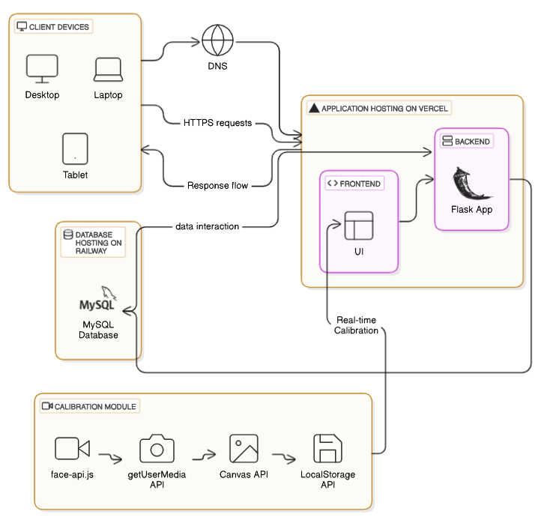

Figure 1: Architecture Diagram

## 4.1 How Our Database is Built

In our project, we used **MySQL**, hosted on **Railway**, to manage and store various types of data critical to our system. The database is organized into multiple tables, each serving a specific purpose:

* **Users**: This table stores user accounts, including their login credentials, registration information, and personalized settings. It serves as the backbone of user authentication and session management.
* **Visual Acuity**: This table records the results of the **Visual Acuity Test**, which measures the sharpness of a user's vision. It enables the tracking of individual user performance over time.
* **Color Vision**: This table contains data from the **Color Vision Test**, which evaluates a user's ability to distinguish between colors. The information stored here helps identify color vision deficiencies.
* **Contrast Vision**: This table manages the results of the **Contrast Sensitivity Test**, which assesses the user's ability to differentiate between shades of gray. The data supports monitoring improvements in contrast perception.
* **Blur Check**: This table stores data from the **Blur Check Test**, designed to detect focusing issues. It provides insights into the user’s ability to focus on images or text.
* **Field of Vision (Watch Dot)**: This table tracks results from the **Field of Vision Test**, which maps the user's peripheral vision. It helps identify blind spots or other issues affecting the user's field of view.

By structuring our database in this way, we ensure that the application can efficiently manage and retrieve the necessary data for providing accurate diagnostics and detailed progress tracking. MySQL’s relational structure and Railway’s hosting services allow us to build a reliable, scalable backend that supports the complex needs of our project.

# 5. Activity Diagram:

## Login Process:

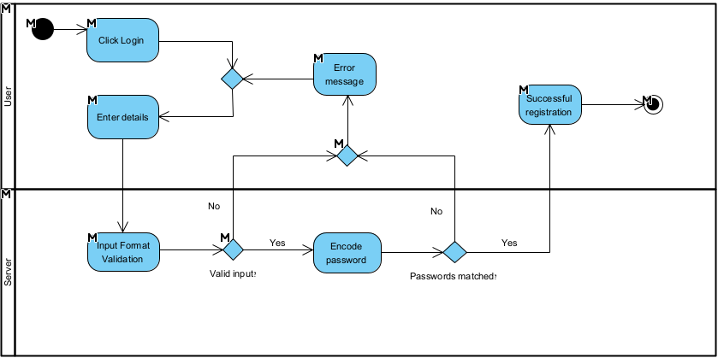This activity diagram represents the process of user authentication in the OptiVision system. It demonstrates how the system handles user input by validating credentials, encoding passwords, and comparing them with stored records. Based on the validation results, the system either grants access to the user or displays an error message, ensuring secure and efficient login functionality.

## Register Process:

This activity diagram outlines the steps for user registration within the system. The process begins with the user entering their details, which are then subjected to input format validation to ensure compliance with basic requirements, such as a valid email format and a sufficiently strong password. The system checks for duplicate accounts by verifying if the email already exists. If valid and unique, the password is securely hashed before saving the user data. Upon successful completion, the system confirms the registration or provides an error message for invalid inputs or existing accounts.

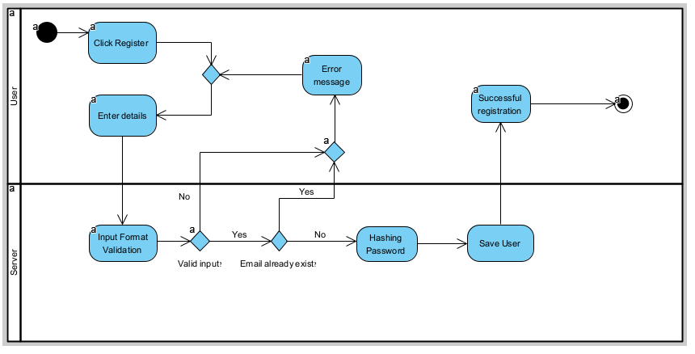

## Visual Acuity Test Process:

This activity diagram outlines the process for conducting a Visual Acuity Test. The user starts the process by calibrating the screen and confirming readiness. The system then displays instructions and presents test items progressively, adjusting the difficulty level based on the user's responses. Each response is validated, and incorrect answers are tracked. If the user provides three incorrect responses, the level is decreased. If responses are correct, the level increases until a maximum threshold is reached. After completing the test for one eye, the system checks if the test for the other eye needs to be conducted. Once all tests are complete, the system displays the results and saves them for future reference, ensuring a comprehensive assessment of the user's visual acuity.

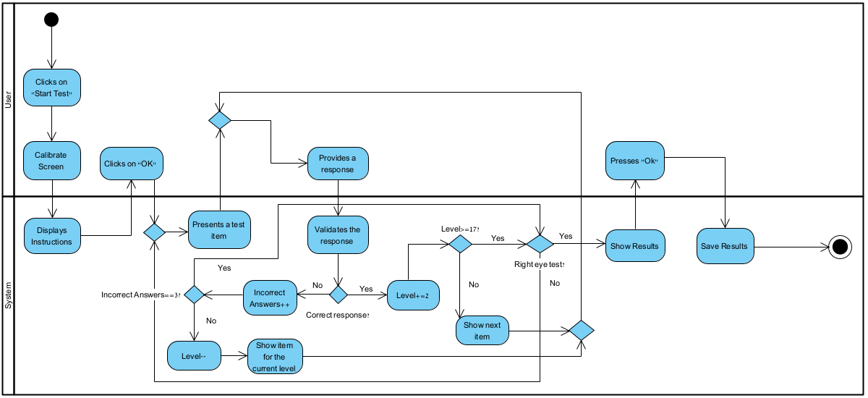

## Color Vision Test Process:

This activity diagram outlines the process for conducting a Color Vision Test. The user initiates the test by clicking "Start Test" and confirming the readiness after viewing the instructions. The system then displays test items one at a time, and the user provides a response. Each response is validated by the system: if correct, the "CorrectAnswers" counter is incremented; if incorrect, the "IncorrectAnswers" counter is incremented.

The process repeats until all test items are completed. The system then displays the results for the user to review. Once the user confirms by clicking "OK," the system saves the results and concludes the process, ensuring all responses are recorded and feedback is provided for future reference.

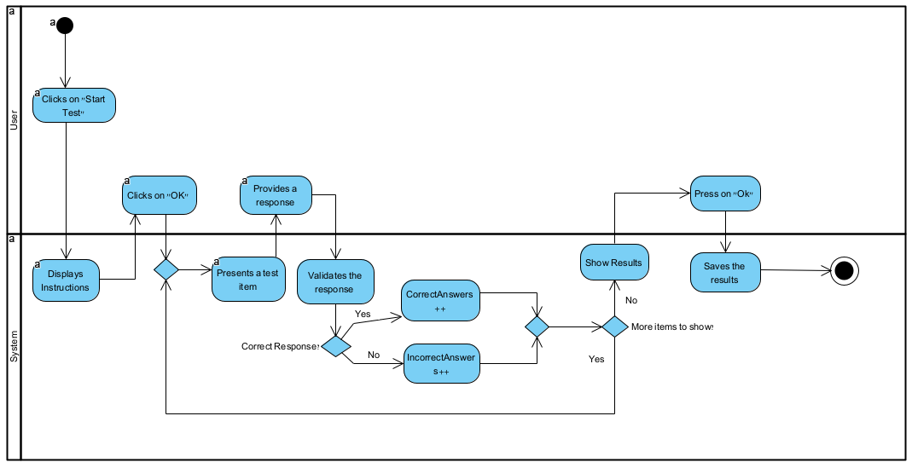

## Contrast Vision Test Process:

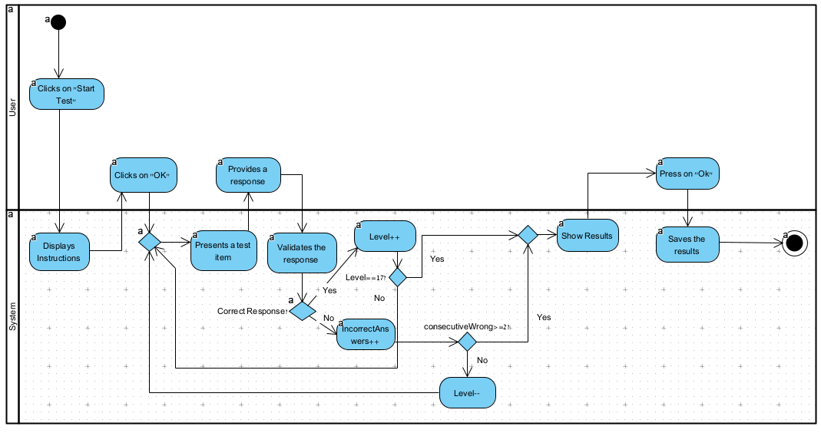This activity diagram outlines the process for conducting a Contrast Vision Test. The user begins by clicking "Start Test" and confirming readiness after viewing the instructions. The system then presents test items one at a time, prompting the user to provide responses. For each response, the system validates it: if correct, the "Level++" counter increases; if incorrect, the "IncorrectAnswers" counter increments. If the user consecutively provides two or more wrong answers, the "Level--" counter decreases, ensuring appropriate test progression. This process continues until the final level is reached or all items are completed. The system then displays the results for the user to review. After the user presses "OK," the system saves the results and concludes the test, ensuring all responses and test performance are recorded for future reference.

## Blur Check Process:

This activity diagram illustrates the process for the **Blur Check Test**. The user initiates the test by clicking "Start Test" and confirming readiness after viewing the instructions. The system proceeds to present test items, validating the user's response at each step. If the response is correct, the level increases ("Level++"); if incorrect, the incorrect answer counter is incremented ("IncorrectAnswers++").

The test continues iteratively until a defined condition is met, such as reaching the maximum test level (checked using "Level == MAX_LEVELS"). If the maximum level is reached, the system displays the results. The user reviews the results and confirms by clicking "OK," after which the system saves the results, completing the process. This ensures a structured evaluation of the user's visual acuity while adapting to their performance.

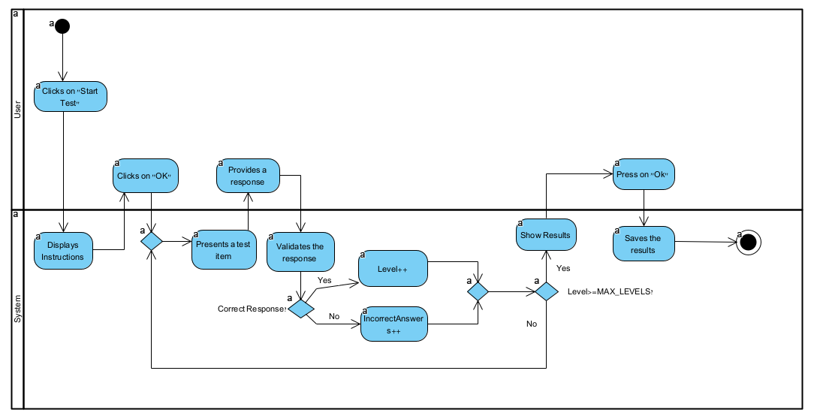

## Watch The Dot Test Process:

This activity diagram outlines the **Dot Test** process as part of the visual evaluation. The user starts the test by clicking "Start Test" and confirming readiness after viewing the instructions. The system proceeds to display the left-eye test, where the user provides responses. Once the left-eye test is completed, the system transitions to the right-eye test, prompting the user for additional responses.

After completing both eye tests, the system displays the results for the user to review. The user confirms the results by clicking "OK," and the system saves the results to conclude the process. This structured approach ensures a comprehensive evaluation of the user's vision for both eyes.

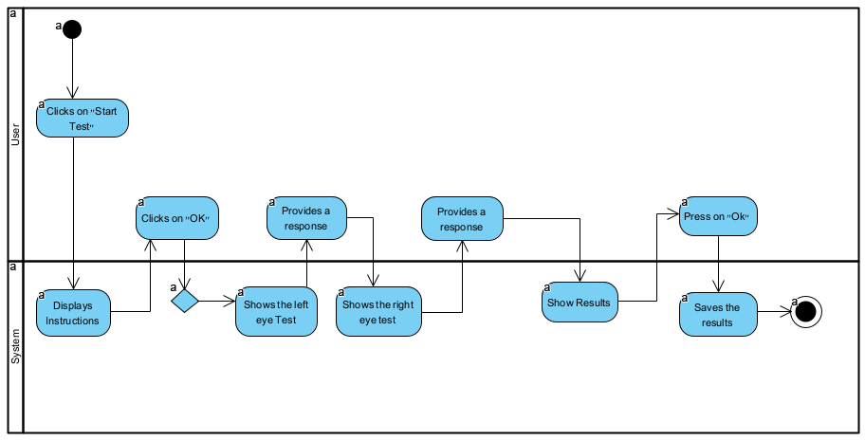

# 6. Project Work Division

To ensure efficient project management and timely delivery, we adopted agile principles throughout the development of the **OptiVision** system. The project was divided into distinct phases, each focusing on specific components and functionalities. Using sprints and iterative development cycles, we ensured incremental progress while maintaining a fully functional and thoroughly tested system. Regular reviews and adjustments were conducted to keep the project aligned with the set objectives.

## Phase 1: Backend Development

* **Task 1: Setting up the Flask Backend**
  + **Sprint**: Develop and configure the backend using Flask, focusing on creating the API endpoints for communication with the frontend and database.
  + **Details**: Core backend functionalities were implemented, including routing, user authentication, and test result handling.
* **Task 2: Database Integration with MySQL**
  + **Sprint**: Design and connect the backend to a MySQL database hosted on Railway.
  + **Details**: The database schema was designed to store user data, test results, and progress history securely and efficiently. CRUD operations were implemented for seamless data management.

## Phase 2: Frontend Development

* **Task 3: Frontend Interface Development**
  + **Sprint**: Build the user interface using Flask’s Jinja2 templating engine, along with HTML, CSS, and JavaScript.
  + **Details**: Created pages for login, dashboard, vision tests, and reports. Implemented a responsive design for usability across devices.
* **Task 4: Calibration Module Implementation**
  + **Sprint**: Develop the calibration module using face-api.js and an alternative ruler-based calibration method.
  + **Details**: Enabled accurate screen calibration to ensure reliable test results. The module adapts to users with or without a camera.
* **Task 5: Test-Specific Pages**
  + **Sprint**: Design and implement individual pages for each test, including Visual Acuity, Color Vision, and Field of Vision.
  + **Details**: Each test page included interactive elements for user input, real-time feedback, and data submission to the backend.

## Phase 3: Testing and Validation

* **Task 6: Unit Testing and Debugging**
  + **Sprint**: Conduct unit testing for all components, including backend APIs, database operations, and frontend interactions.
  + **Details**: Identified and resolved bugs in data handling, test workflows, and user interface responsiveness.
* **Task 7: User Testing**
  + **Sprint**: Gather feedback from a small group of users on the system’s functionality and ease of use.
  + **Details**: Adjusted features and workflows based on user feedback to improve the overall experience.

## Phase 4: Deployment

* **Task 8: Frontend Deployment on Vercel**
  + **Sprint**: Deploy the frontend on Vercel for hosting and ensure smooth integration with the backend.
  + **Details**: Configured routing and tested API calls between the frontend and backend.
* **Task 9: Database Hosting on Railway**
  + **Sprint**: Set up the MySQL database on Railway and integrate it with the backend.
  + **Details**: Ensured secure and reliable data storage with scalable hosting.
* **Task 10: Securing Communication with HTTPS**
  + **Sprint**: Implement HTTPS for secure client-server communication.
  + **Details**: Configured SSL certificates and ensured that all sensitive user data is encrypted.

## Phase 5: Report Generation and Finalization

* **Task 11: PDF Report Generation**
  + **Sprint**: Integrate FPDF library to generate detailed, downloadable PDF reports for users.
  + **Details**: Designed and implemented professional-looking reports summarizing user progress and test results.
* **Task 12: System Optimization**
  + **Sprint**: Fine-tune the system for performance and scalability.
  + **Details**: Optimized backend queries, frontend loading times, and calibration accuracy.

# 7. Challenges

During the development of the **OptiVision** system, we encountered several challenges that required creative solutions and significant problem-solving efforts. Below is a summary of the key challenges and how we addressed them:

* + - **Designing Accurate and User-Friendly Vision Tests**

Developing accurate vision tests that also provided a seamless user experience was a key challenge.

* **Challenge**: Ensuring the vision tests (e.g., Color Vision Test, Blur Check) were accurate, easy to use, and worked consistently across devices.
* **Solution**: We conducted thorough research on test methodologies, such as Ishihara plates for color vision and blur simulations for focus tests. Iterative user testing helped refine the test workflows and ensure they were intuitive and reliable.
* **Ensuring Accurate Screen Calibration**

The system required precise screen calibration for accurate vision tests, which posed a challenge for users without cameras.

* **Challenge**: Providing an alternative calibration method for users without access to a webcam.
* **Solution**: We developed a ruler-based calibration method, allowing users to adjust the on-screen scale to match a 5 cm line in real life. This provided a flexible solution that maintained the accuracy of the tests.
* **Frontend Responsiveness Across Devices**

Creating a responsive interface that worked seamlessly across various devices posed significant design challenges.

* **Challenge:** Ensuring the interface adapted to different screen sizes while maintaining usability for vision tests.
* **Solution:** Percentage-based dimensions and CSS media queries were used to tailor the design for different screen sizes, ensuring compatibility with desktops, tablets, and smartphones. Extensive testing was conducted to validate responsiveness.
* **Deployment on Multi-Platform Technologies**

Deploying the application across multiple platforms, including Vercel for the frontend and Railway for the database, was a complex task.

* **Challenge**: Coordinating deployment between different technologies and ensuring seamless integration.
* **Solution**: We configured the Vercel platform for the frontend, allowing smooth interaction with the Railway-hosted MySQL database. Comprehensive testing ensured that communication between components remained stable post-deployment.
* **Efficient Report Generation**

Generating detailed, user-friendly reports summarizing test results presented unique challenges.

* **Challenge**: Ensuring that PDF reports were both visually appealing and accurately represented user data.
* **Solution**: We utilized the FPDF library for generating custom PDF reports, incorporating graphics, tables, and detailed summaries of user test results.
* **Calibration Accuracy with face-api.js**

Implementing real-time video-based calibration using face-api.js for distance measurement was a novel feature.

* **Challenge**: Achieving accurate results despite variances in user environments, such as lighting or camera quality.
* **Solution**: We fine-tuned the calibration logic to account for these variances and provided visual feedback during calibration to guide users through the process.
* **User Testing and Feedback**

Gathering and incorporating user feedback to refine system usability and accuracy posed ongoing challenges.

* **Challenge**: Addressing varied user needs and ensuring the system was intuitive for all demographics.
* **Solution**: Iterative user testing cycles were conducted, during which feedback was gathered and improvements were implemented in areas such as navigation, test instructions, and error messaging.

# 8. Interface with the Client Throughout Development

Throughout the development of the **OptiVision** application, we consistently engaged with potential users, including individuals with vision impairments and experts in the field of optometry. This iterative process allowed us to create a user-friendly interface tailored to meet the needs of all users.

To ensure a visually calming and accessible design, we carefully selected colors that are easy on the eyes. The interface primarily uses shades of white, light gray, and blue, which evoke a sense of clarity and focus. Contrasting colors, such as green and orange, are used sparingly to highlight key elements like buttons and alerts. Red is reserved for critical messages, such as error notifications, to ensure users quickly identify important information.

Understanding that many users might be unfamiliar with vision tests or technology, we designed the interface to be intuitive and free of distractions. Each test includes clear, step-by-step instructions and visual aids to guide the user through the process. The interface also incorporates large, readable text and high-contrast elements to accommodate users with limited vision.

During the development phase, we actively sought feedback from a diverse group of testers:

* **User Testing**: We invited individuals with varying levels of vision impairment to interact with the application and provide feedback. This helped us identify and address challenges they faced while navigating the system.
* **Experts in Vision Care**: Optometrists reviewed the application to ensure the accuracy of the tests and the usability of the interface. Their suggestions, such as refining the calibration process and simplifying the report layout, were incorporated into the final design.

One key recommendation from users was to include a tutorial for the calibration process. In response, we added a short, animated walkthrough to demonstrate how to set up the screen calibration using either a webcam or a physical ruler. This addition significantly reduced confusion and improved the overall user experience.

Before deployment, we tested the application locally and collected additional feedback:

* A user suggested providing audio instructions for certain tests, which we integrated to make the application more accessible for individuals with limited reading abilities.
* Another tester requested the ability to view detailed explanations of test results, which led to the inclusion of a "Help" section within the reports dashboard.

After deployment, we conducted a final review session with a group of optometry professionals, who praised the application for its intuitive interface and comprehensive functionality. They highlighted the clarity of the reports and noted that the application's design is well-suited for both individual users and healthcare professionals.

Taking all feedback into account, we refined the user interface to ensure it met the needs of a wide audience, from those taking vision tests at home to professionals analyzing test results. By continuously engaging with users and experts throughout development, we were able to deliver an application that is accessible, functional, and optimized for an exceptional user experience.

# 9. User Experimentation and Testing Methodology

To ensure that the **OptiVision** application delivers a secure, reliable, and user-friendly experience, we conducted a comprehensive testing process focusing on user interaction, system performance, and data security. Below are the primary testing methodologies employed:

## 1. Navigation Test

* **Objective**: Validate that users can seamlessly navigate through the application’s interface across various devices and screen sizes.
* **Process**:
  + Tested the navigation bar, which includes links to **Dashboard**, **Reports**, **Settings**, and individual vision tests.
  + Conducted manual testing by clicking each link repeatedly to ensure proper functionality.
  + Used automated tools to simulate different screen sizes and browsers, verifying that the design is fully responsive.
* **Outcome**:
  + All navigation links were confirmed to work without broken links or rendering issues.
  + The responsive design successfully adapted to desktops, laptops, and tablets.

## 2. User Authentication Testing

* **Objective**: Ensure that only authorized users can access the application and their data.
* **Process**:
  + Tested the **registration** and **login** processes with valid and invalid credentials.
  + Verified that password criteria were enforced and that appropriate error messages appeared for non-compliant passwords.
  + Simulated multiple user sessions to confirm that session management worked as intended, including timeouts for inactive sessions.
* **Outcome**:
  + Registration and login mechanisms were found to function seamlessly.
  + Password validation and error handling were effective in preventing weak passwords.

## 3. Test Filtering and Reporting Validation

* **Objective**: Confirm that users can accurately filter test results and generate reports.
* **Process**:
  + Tested the date and test-type filters in the **Reports** section to verify they accurately display relevant results.
  + Ensured that downloading **PDF reports** generated correct and comprehensive summaries of user test results.
* **Outcome**:
  + Filters worked correctly across all test types and date ranges.
  + PDF reports were generated accurately, matching the data displayed in the interface.

## 4. Private Routes and Security Testing

* **Objective**: Prevent unauthorized access to restricted sections, such as user-specific data or reports.
* **Process**:
  + Attempted to access private routes (e.g., **Dashboard**, **Reports**) by directly entering the URLs without logging in.
  + Verified that the system redirected unauthorized users to the login page.
  + Used **Postman** to test communication between the frontend and backend, ensuring secure handling of requests and responses.
* **Outcome**:
  + Unauthorized access attempts were successfully blocked.
  + Backend security protocols ensured proper data handling and encryption.

## 5. Calibration Module Testing

* **Objective**: Validate the accuracy of screen calibration for vision tests.
* **Process**:
  + Tested the **webcam-based calibration** (using **face-api.js**) under different lighting and environmental conditions to ensure consistent performance.
  + Evaluated the **ruler-based calibration** method by measuring screen-to-user distance accuracy and verifying scaling adjustments.
* **Outcome**:
  + Both calibration methods were found to perform reliably, with clear instructions ensuring ease of use for all users.

## 6. Multi-Browser and Device Testing

* **Objective**: Ensure compatibility across popular browsers and devices.
* **Process**:
  + Tested the application on browsers such as **Chrome**, **Firefox**, **Edge**, and **Safari**.
  + Verified functionality on desktops, laptops, and tablets to confirm consistent performance and design.
* **Outcome**:
  + The application worked flawlessly across all tested browsers and devices, maintaining consistent responsiveness and functionality.

# 10. Experiment and Evaluation

This section outlines the experiments conducted to test the functionality of the OptiVision system, as well as the evaluation and verification methods employed to ensure that the application meets its predefined requirements. Through comprehensive testing and feedback, we validated the system’s effectiveness in delivering accurate and user-friendly vision assessments.

## 10.1 Experiment

To evaluate the OptiVision system, we conducted testing in three phases, simulating real-world conditions and engaging a diverse group of users. This allowed us to ensure that the system performs reliably across varying environments and scenarios.

* **Phase 1: Supervised Testing with Volunteers**  
  The first phase involved inviting colleagues and volunteers to test the application under our direct supervision. Each participant completed the full suite of vision tests, including **Visual Acuity**, **Color Vision**, **Contrast Sensitivity**, **Blur Check**, and **Field of Vision** tests. User interactions and feedback were recorded to identify areas for improvement. This phase focused on verifying the system’s core functionality, calibration accuracy, and responsiveness.
* **Phase 2: Mixed Supervision Testing**  
  During this phase, participants tested the system in both supervised and unsupervised environments. Half of the participants completed the tests in a controlled lab setting, while the rest did so remotely using their personal devices. The goal was to assess the consistency of test results and user experience between these two environments. Data from both groups was analyzed to ensure that the system remained accurate and user-friendly, regardless of supervision.
* **Phase 3: Fully Remote Testing**  
  In the final phase, the system was deployed for entirely remote testing. Participants used the application independently, following on-screen instructions for calibration and completing tests without assistance. Feedback collected during this phase provided insights into the system’s usability, error handling, and instructional clarity in unsupervised settings.

Through these three phases, we captured diverse user interactions, enabling us to refine the system and ensure its robustness in real-world applications.

## 10.2 Verification and Evaluation

To ensure the reliability, accuracy, and usability of the OptiVision system, we conducted rigorous verification and evaluation procedures. These included comprehensive functional and acceptance testing of all key components.

### 10.2.1 Functional Testing

We conducted detailed functional tests across the following system modules:

* **Input Hardware**: Verified the system’s ability to access and process input from the user’s webcam (for calibration), mouse, and keyboard. The system successfully handled real-time video input, user clicks, and form submissions as intended.
* **Web Application**: Tested page load times, responsiveness, and interface design. All pages, including the dashboard, test pages, and reports section, loaded within 2 seconds and rendered correctly across different devices and screen sizes.
* **Calibration Module:** 
  + **Webcam Distance Measurement:** The system uses the webcam to measure the user's distance from the screen. This ensures accurate visual test results by analyzing facial landmarks in real time. The module provided clear feedback during the process, allowing users to adjust their position for optimal calibration.
  + **Ruler-Based Calibration:** The system offers a manual calibration method for users without access to a webcam. Users adjust an on-screen line to match a physical ruler's 5 cm length, ensuring accurate scaling of test elements.
* **API Communication**: Verified the seamless exchange of data between the frontend and backend using JSON. All endpoints, including those for test submission, report generation, and user authentication, performed as expected.

### 10.2.2 Acceptance Testing

Beyond functional testing, acceptance tests were conducted to ensure the system meets all user requirements:

* **Test Accuracy**: Each vision test (e.g., Visual Acuity, Color Vision) was evaluated for accuracy and consistency. Results matched expected outcomes across multiple test runs.
* **Error Handling**: Edge cases, such as invalid calibration settings or incomplete test submissions, were tested. The system handled errors gracefully by displaying user-friendly messages and guiding users to resolve the issue.
* **Reports and Progress Tracking**: Validated the functionality of the reports section, ensuring users could access detailed results, view progress over time, and download professional PDF summaries.

## 10.3 Key Acceptance Test Results

1. **Calibration Accuracy**:

• **Webcam Distance Measurement**: Delivered precise distance measurements, with clear instructions guiding users to maintain the correct position.

• **Ruler-Based Calibration**: Ensured reliable and consistent screen scaling for all users.

1. **Web Application**: The system maintained high responsiveness and displayed content accurately across devices.
2. **User Authentication**: Secure login and password reset mechanisms were verified for functionality and security.
3. **Reports**: PDF reports were generated correctly, including accurate test results and progress graphs.
4. **Visual Acuity Test Experiment**

To validate the effectiveness of the Visual Acuity Test, we conducted an experiment with 14 participants who have known visual acuityimpairments.

**Findings:**

* **13 out of 14 participants** (92%) received results indicating they have a visual acuity problem, demonstrating the test's accuracy in detecting impairments.
* Most participants **struggled at higher difficulty levels**, confirming that the test effectively scales based on user ability.
* **Elderly participants** faced greater challenges, with some **failing to reach Level 10**, suggesting a need for potential test adjustments or accessibility improvements.

These findings support the reliability of OptiVision in identifying vision impairments (92% accuracy), while also highlighting areas for future refinement, particularly for elderly users.

## 10.4 Areas for Improvement

While the system met the majority of its functional and performance requirements, some areas for enhancement were identified:

* **Page Load Times**: Optimizing static files (CSS, JavaScript) and increasing server resources could further improve page load speeds.
* **Calibration Instructions**: Adding a video tutorial for calibration methods could make the process easier for first-time users.
* **Extended Testing**: Expanding the scope of testing to include a larger, more diverse user base would provide additional insights into system performance.

Through rigorous experimentation, functional testing, and acceptance evaluation, the OptiVision system demonstrated its effectiveness in delivering accurate, user-friendly vision tests. These processes ensured the system is ready for real-world deployment, meeting the needs of diverse users.

# 

# 11. References

## 11.1 GitHub Link:

<https://github.com/TameerAmer/Capstone-Project.git>

## 11.2 Academic References:

[1] World Health Organization. (2019). *World report on vision*.

[2] World Health Organization. (2021). *Blindness and vision impairment*.

[3] Courtright, P., Mathenge, W., Kello, A. B., & Cook, C. (2021). Primary health care facility readiness to implement primary eye care in Kenya: a cross-sectional study. *BMC Health Services Research, 21*(1), 1360.

[4] Snellen, H. (1862). The Snellen chart for visual acuity testing. *British Journal of Ophthalmology*.

[5] Rosenfield, M. (2011). Computer vision syndrome: A review of ocular effects. *Optometry and Vision Science, 88*(10), 739–746.

[6] Solé-Casals, J., Serra-Llansana, I., & Monné-Llopis, J. (2023). Comparison of two visual-verbal tests for ocular motility assessment. *Journal of Optometry, 16*(1), 34-45.

[7] Tobii Technology AB. (2023). Using eye-tracking technology to diagnose eye movement disorders. *Tobii Customer Stories*.

[8] Birch, J. (2012). Worldwide prevalence of red-green color deficiency. *Journal of the Optical Society of America A, 29*(3), 313-320.

[9] Pelli, D. G., & Bex, P. (2013). Measuring contrast sensitivity. *Vision Research*, 90, 10–14.

[10] Cole, B. L. (2004). The handicap of abnormal colour vision. *Clinical and Experimental Optometry*, 87(4-5), 258–275.

[11] Anstice, N. S., & Thompson, B. (2014). The measurement of visual acuity in children: An evidence-based update. *Clinical and Experimental Optometry*, 97(1), 3–11.

[12] Bourne, R. R. A., et al. (2017). Causes of vision loss worldwide, 1990–2010: A systematic analysis. *The Lancet Global Health*, 5(12), e1221-e1234.

[13] The Vision Council. (2020). *Eyes Overexposed: The Digital Device Dilemma*. Available online.

[14] Nielsen, J., & Norman, D. (2013). The usability of healthcare technologies. *Journal of Usability Studies*, 8(3), 93–104.



# User Documentation

**24-2-D-23**

Tameer Amer 322836388

Redan Ganim 209003474

Mentor: Dr. Natali Levi

**User Documentation**

Welcome to the OptiVision user documentation. OptiVision is an advanced screening system designed to assist in the early detection of eye health issues through a series of specialized vision tests. The system incorporates user-friendly interfaces and adaptive algorithms to evaluate various aspects of visual performance, providing personalized feedback and recommendations.

This documentation will guide you through the features and functionalities of OptiVision, offering step-by-step instructions to ensure you can maximize the system's potential. Whether you're taking the Visual Acuity Test, exploring the Color Vision Test, or reviewing your performance and recommendations, this guide has everything you need.

OptiVision includes five key tests:

1. **Visual Acuity Test** – Measures your ability to see details at various distances.
2. **Color Vision Test** – Assesses your ability to distinguish colors and identify potential deficiencies.
3. **Contrast Sensitivity Test** – Evaluates your ability to discern objects against varying backgrounds.
4. **Blur Test** – Simulates varying levels of blur to measure visual clarity.
5. **Field of Vision Test** – Checks the range of your peripheral vision.

With OptiVision, early detection and proactive vision care are within your reach. Let this guide help you navigate the system and achieve the best outcomes for your vision health.

**17.1** **Documentation for users**

To visit our system and benefit from the services offered, please click the following link: <https://optivision.vercel.app/>

* **Landing Page:**

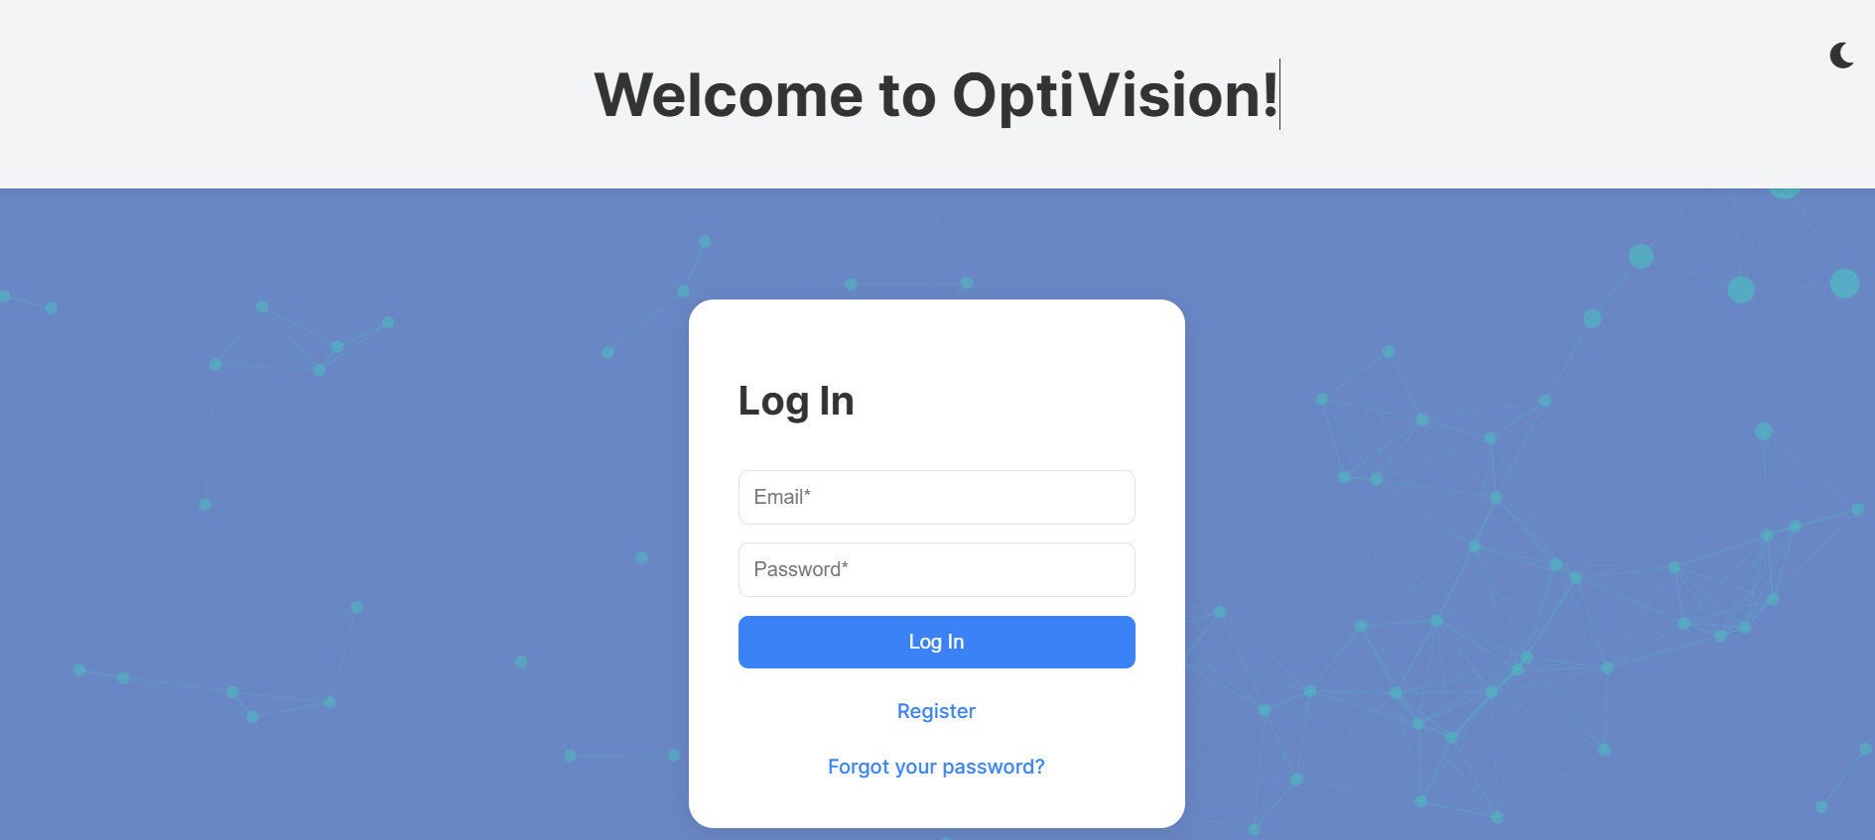

This is the login page for the OptiVision application. It provides users with the ability to log in using their email and password credentials. It also includes options to register for a new account and recover a forgotten password.



This is the dark mode toggle, located in the top-right corner, allows you to switch between light and dark modes for a more comfortable viewing experience. This toggle is available not only on the login page but also throughout other sections of the application, ensuring a consistent and customizable interface across all pages.

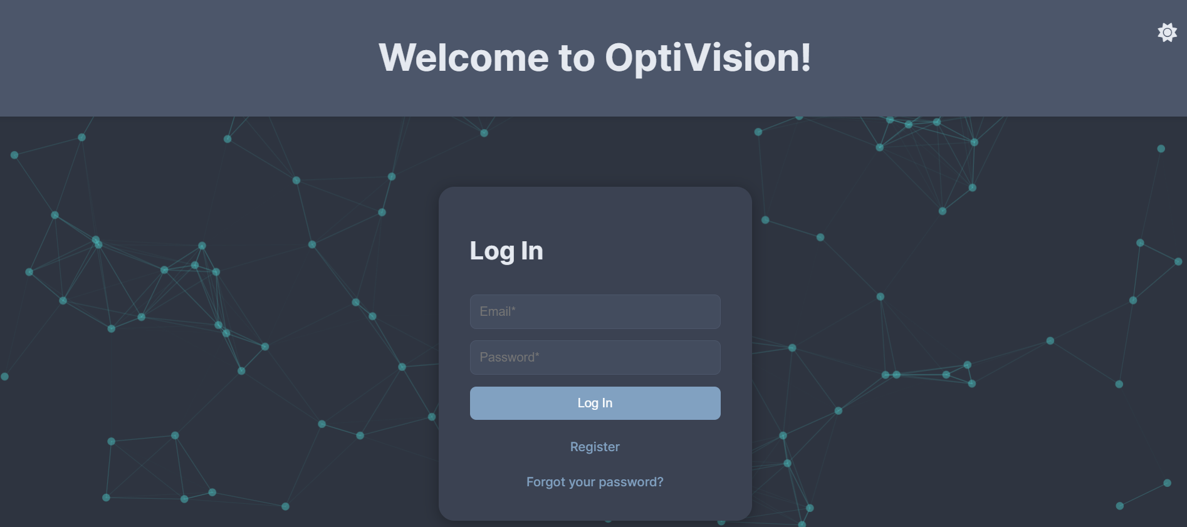

This is the login page in dark mode, activated via the toggle at the top-right corner. Dark mode provides a visually comfortable experience, especially in low-light environments. This feature is available across multiple pages in the application, ensuring a consistent and customizable user interface tailored to your preferences.

* **Register:**



By clicking on "Register", you will render the register page.

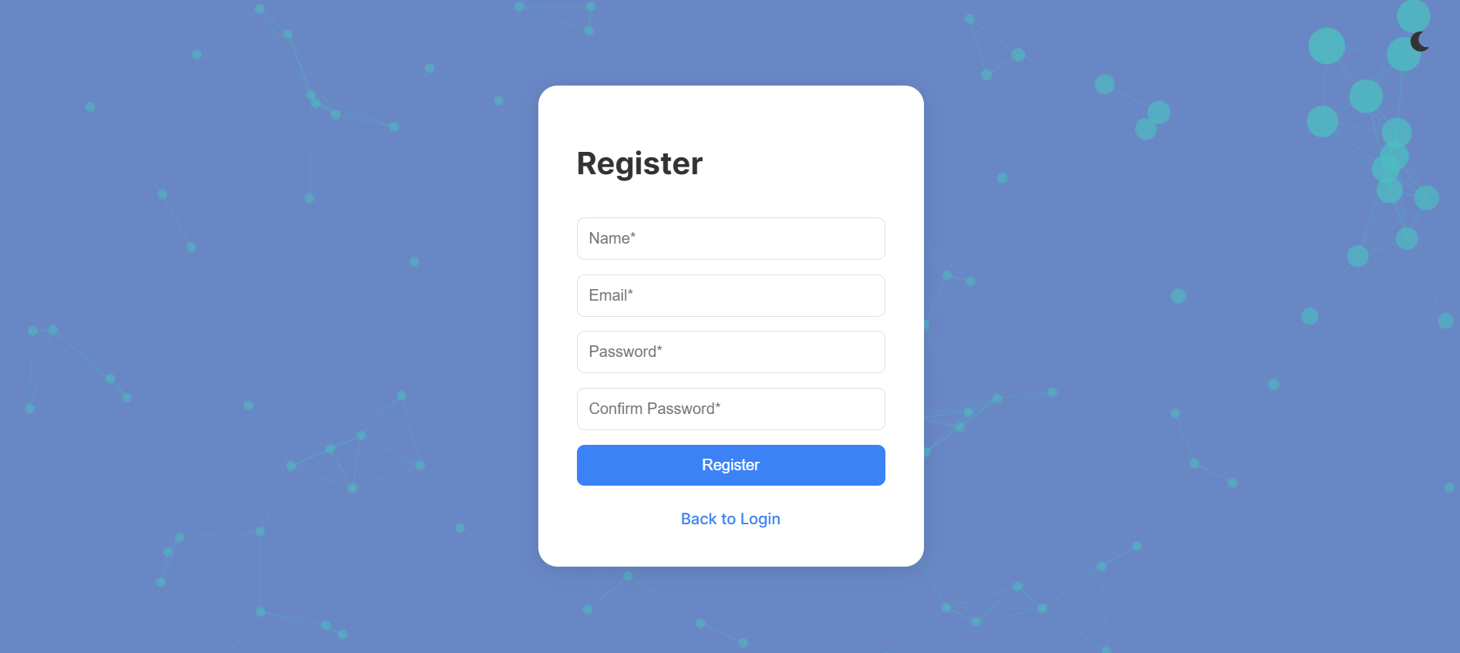

This is the registration page for the OptiVision application. It allows new users to create an account by providing their name, email, and password. The **Confirm Password** field ensures added security by verifying the password entry. Once the required fields are filled, users can click **Register** to complete their registration.

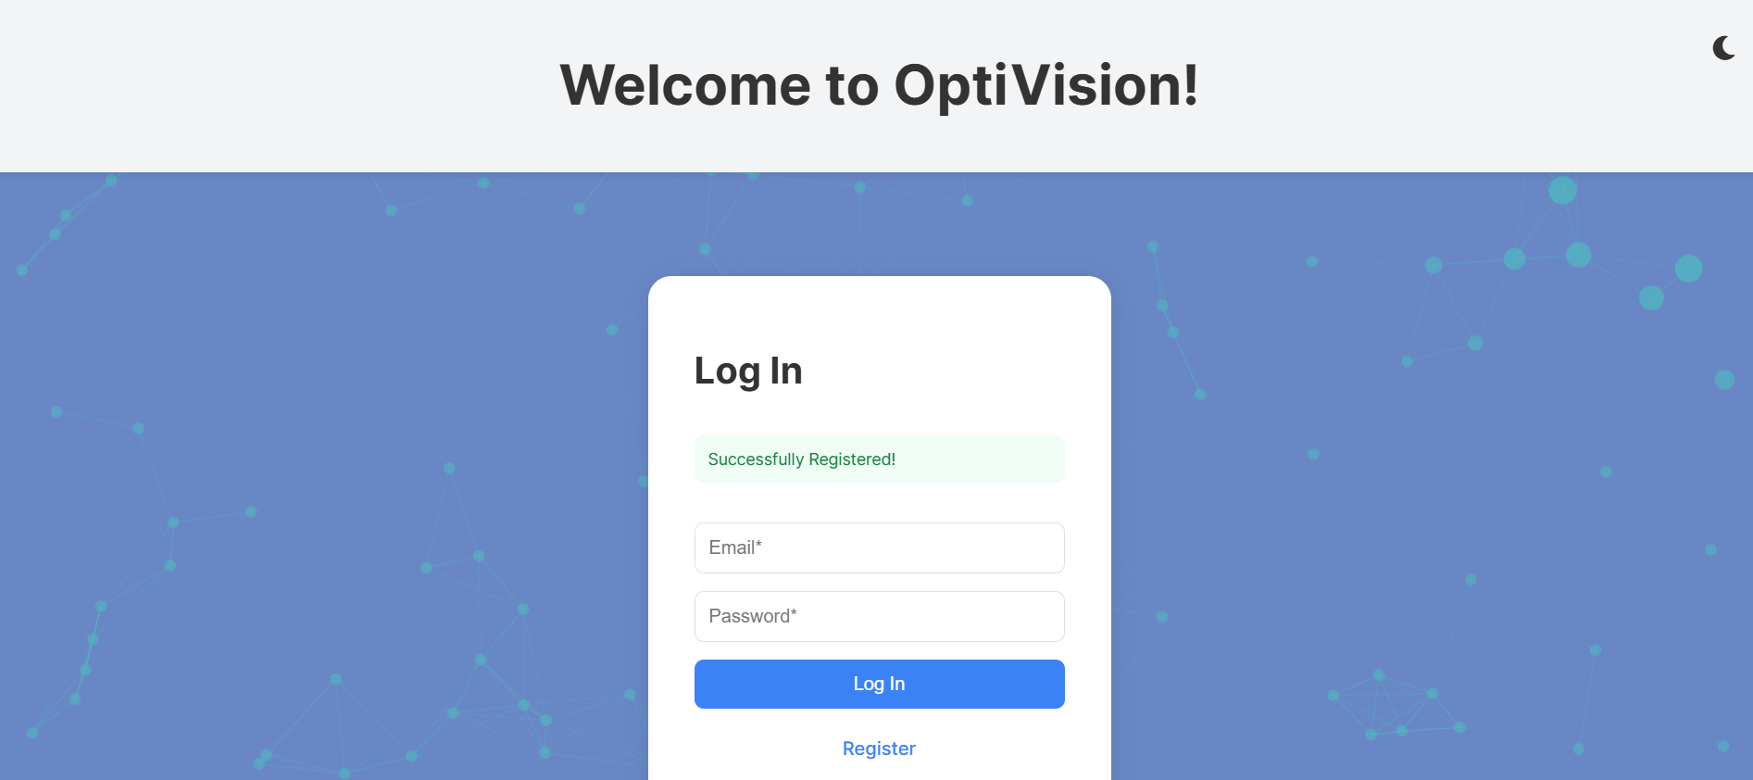

After successfully registering process, you will be rendered back to the login page with a successful message "Successfully Registered"

* **Forgot password:**



By clicking on "Forgot your password" you will be rendered to the request password reset page.

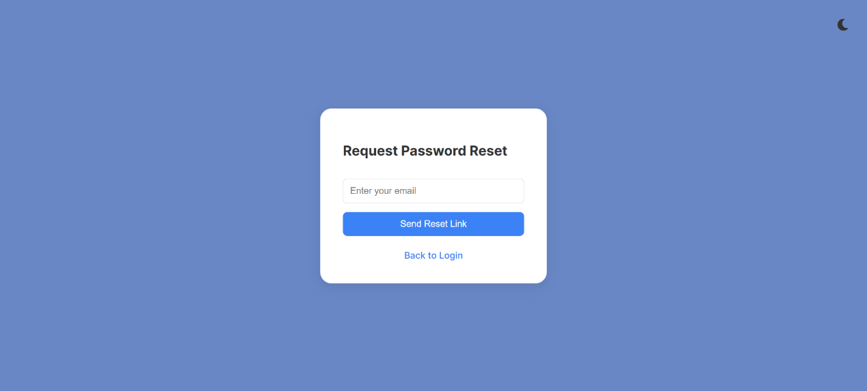

This is the password reset page for the OptiVision application. Users can request a password reset by entering their registered email address and clicking on the **"**Send Reset Link" button. A link to reset the password will be sent to the provided email.

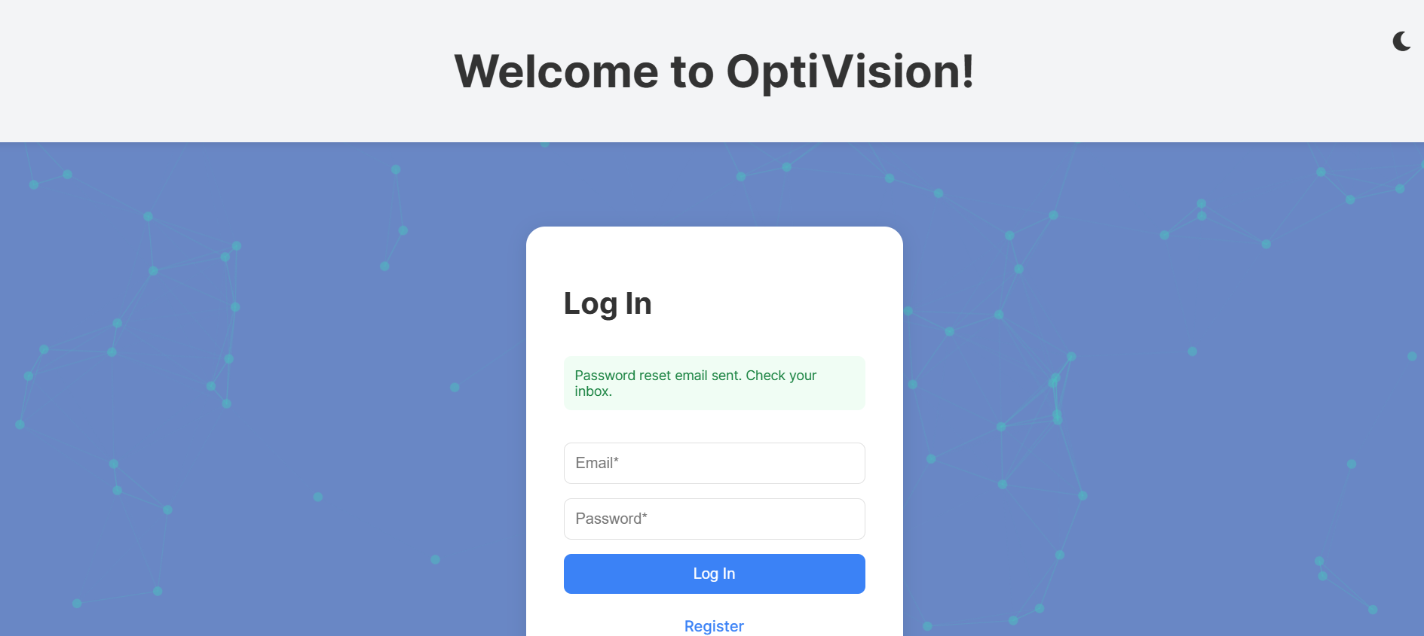

After successfully mail sending, you will be rendered back to the login page with a successful message "Password reset email sent. Check your inbox"

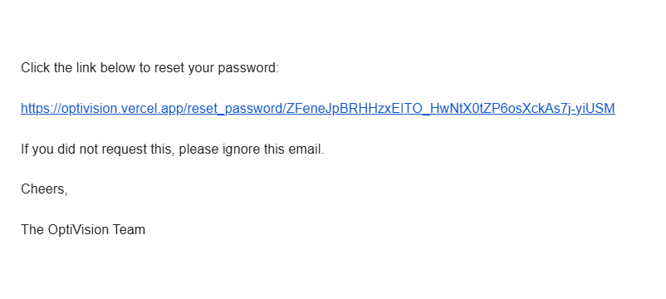

You will receive this email in your inbox, after clicking on the link, you will be rendered to "Reset your password" page.

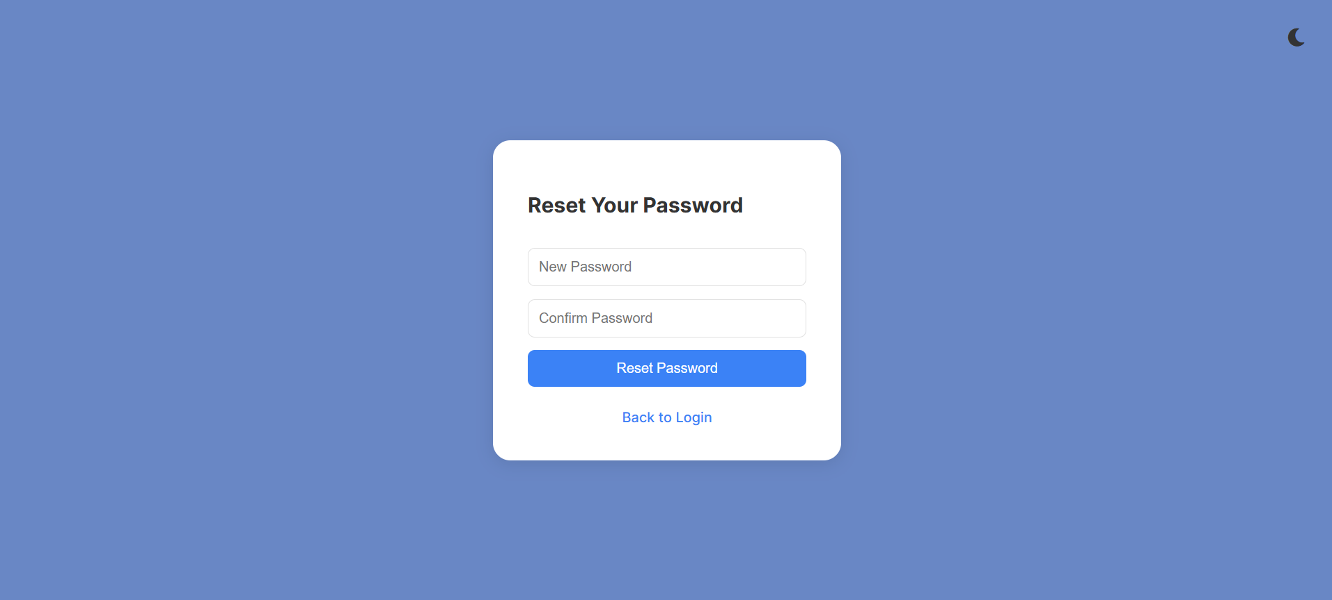

This is the password reset page for the OptiVision application. Users can set a new password by entering it in the **New Password** field and confirming it in the **Confirm Password** field. Once completed, clicking on the **Reset Password** button will finalize the process.

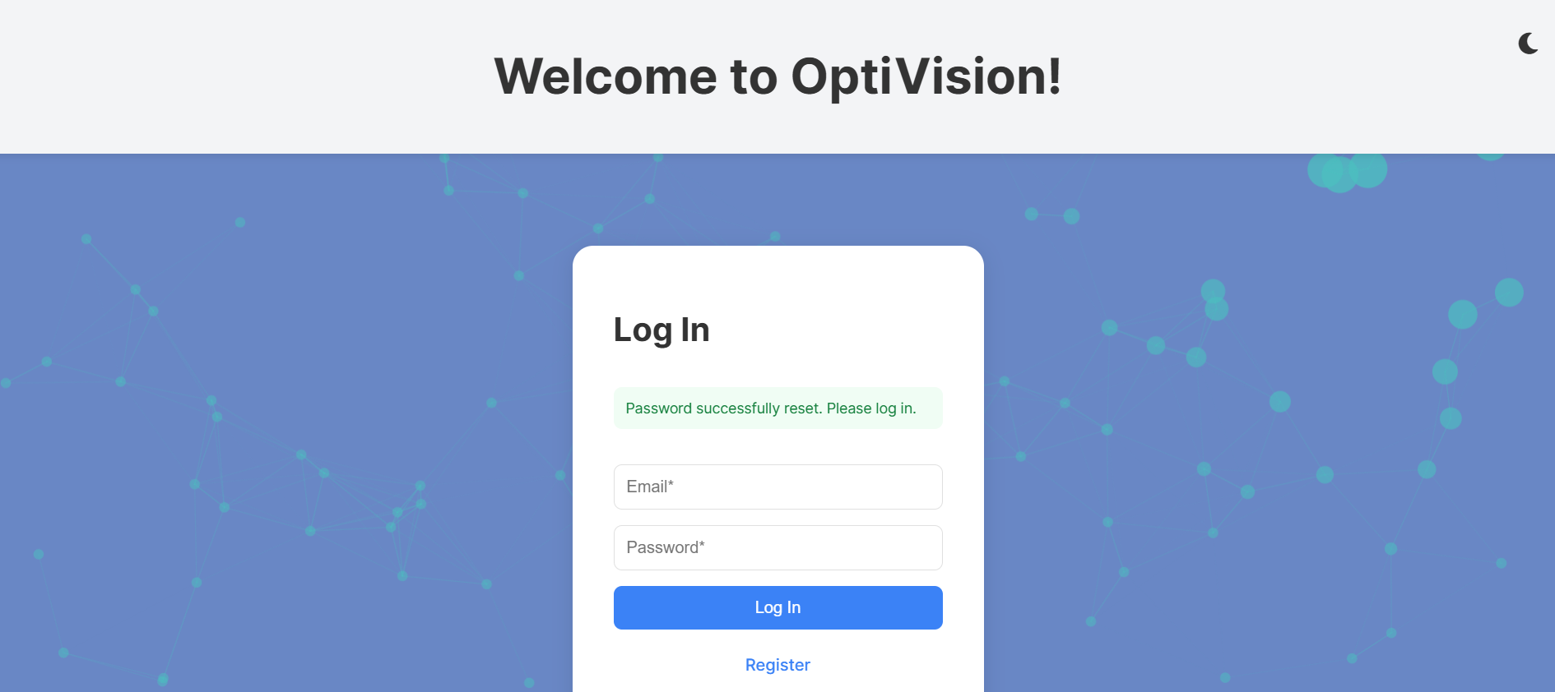

After successfully resetting password, you will be rendered back to the login page with a successful message "Password successfully reset. Please log in."

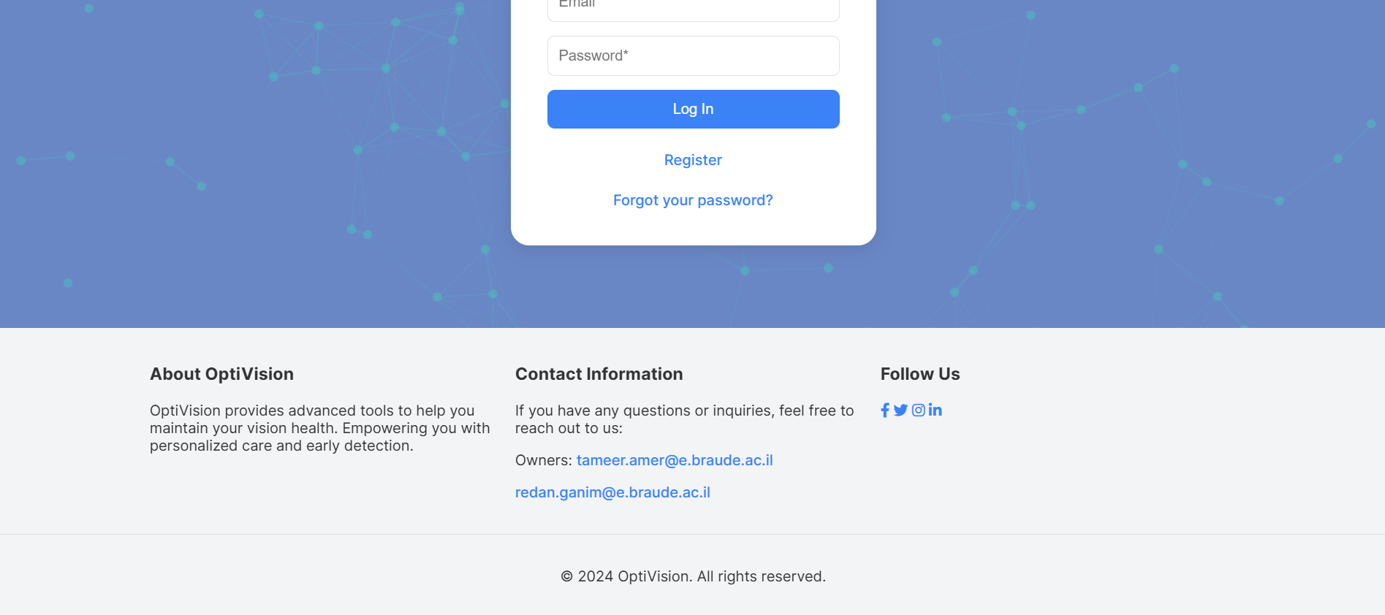

This is the footer section of the OptiVision application. It provides you with additional information about the system, including a brief description of its purpose to empower you with advanced tools for maintaining your vision health. You can find **Contact Information**, including email addresses to reach out if you have questions or need assistance. The **Follow Us** links connect you directly to OptiVision’s social media pages, keeping you updated on the latest features and announcements. At the bottom, copyright information is included to ensure a professional and polished experience.

* **Side Bar:**
* **Dashboard:**

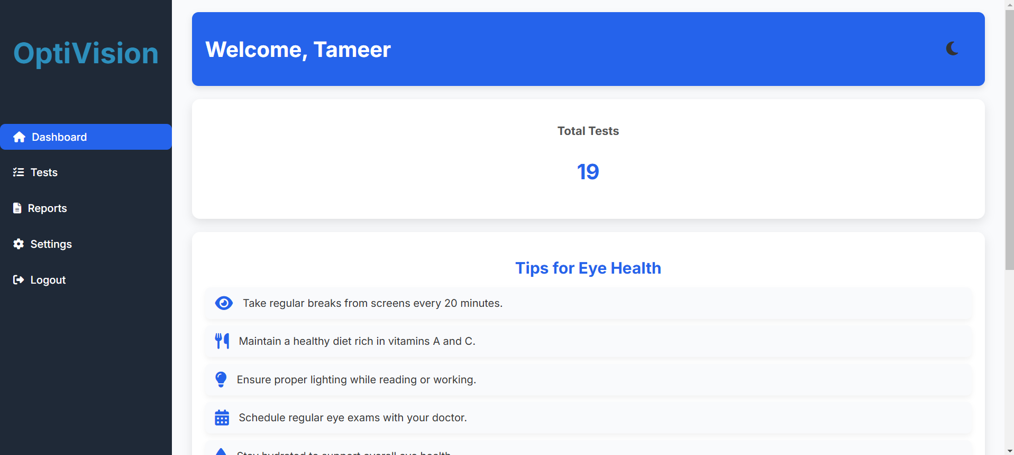

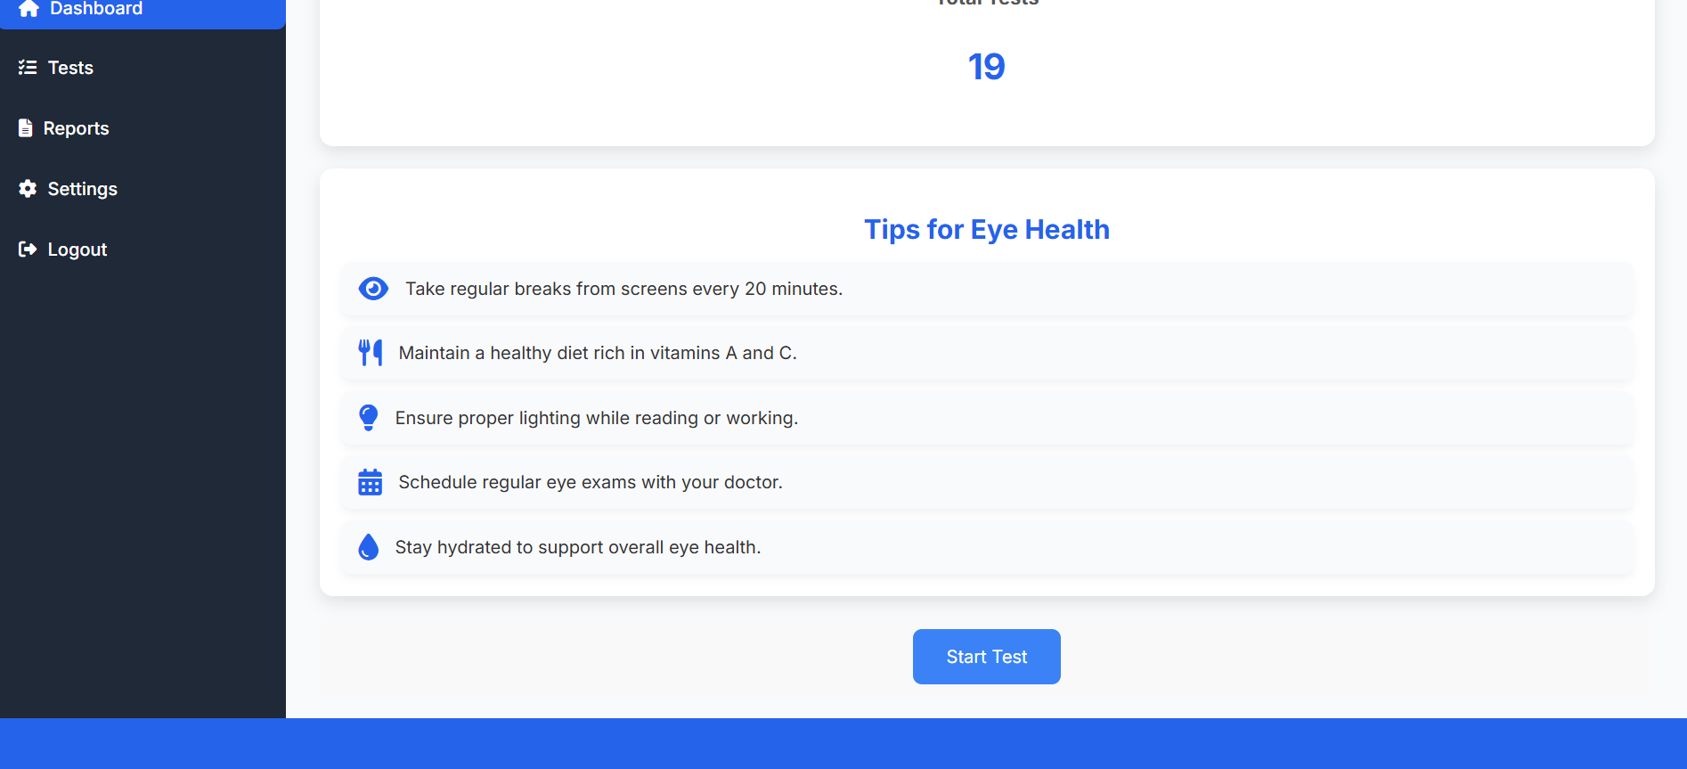After successfully login process, you will be rendered to the "Dashboard" page, where you’re welcomed with a personalized greeting. It shows your **Total Tests** counter you've done and provides **Tips for Eye Health** to support your vision. Use the left menu to access **Tests**, **Reports**, **Settings**, or **Logout** for a smooth experience.  
In addition, if you scroll down a little bit, you will find a "Start Test" button that will take you to the test selection page.

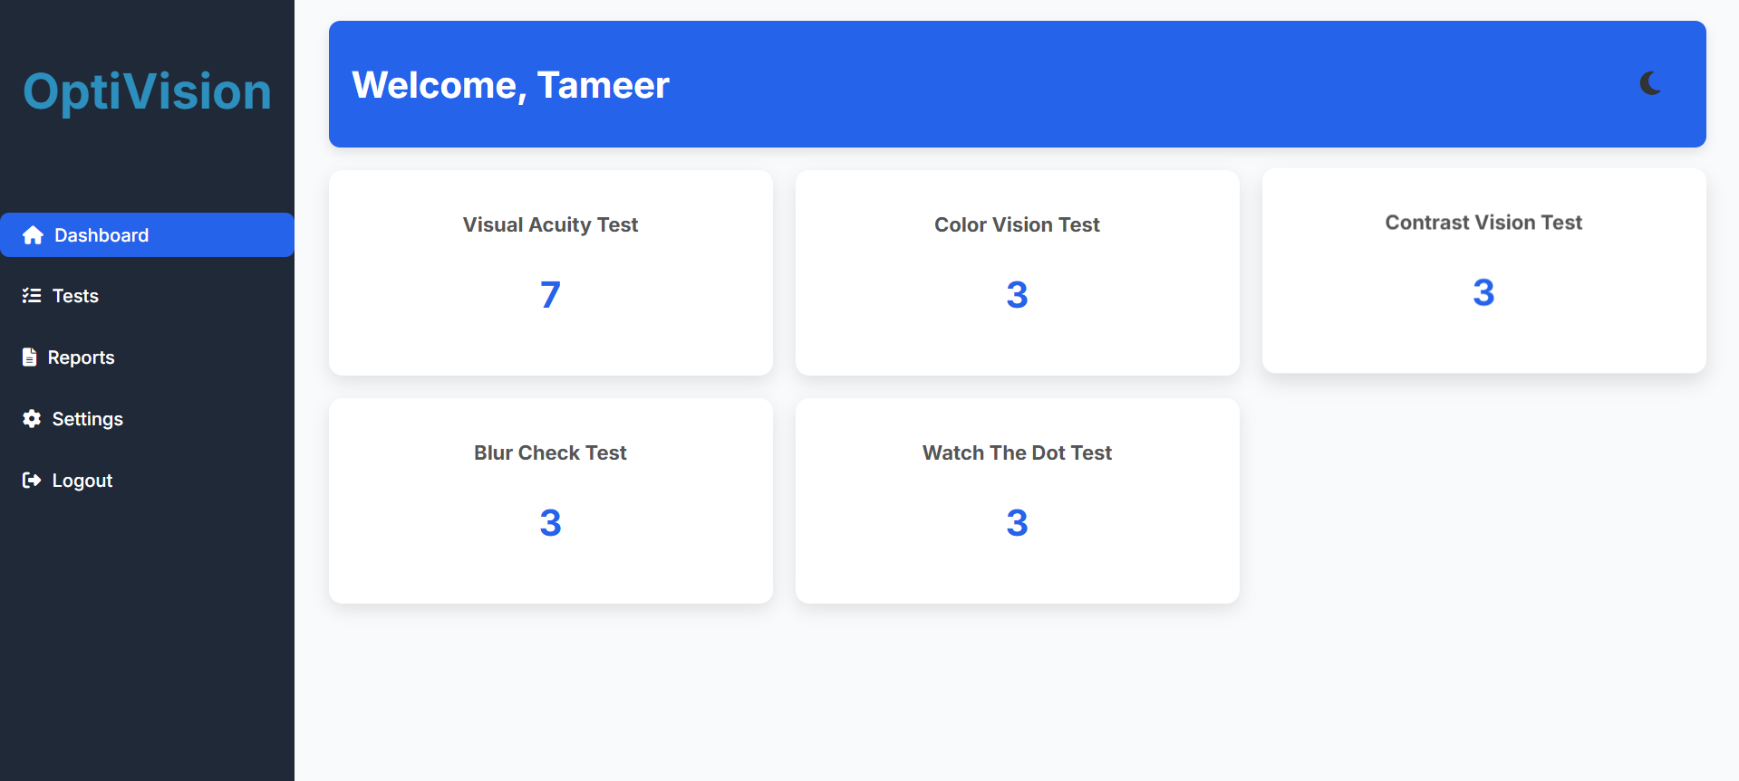

On this page, you can select the test that you want to perform. after choosing a test, you will be rendered to the selected test page.

* + **Tests:**

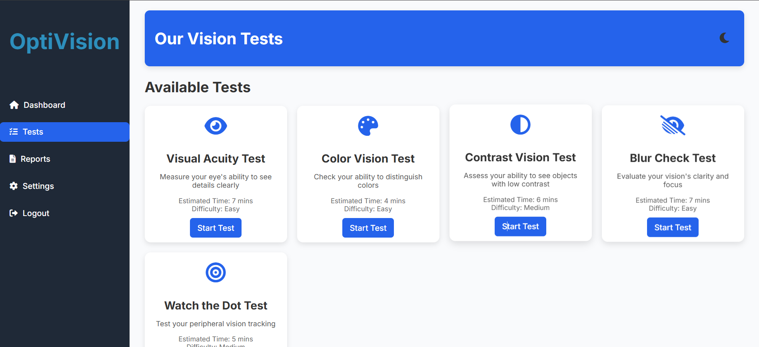

This is the Tests page of the OptiVision application, where you can select from a variety of vision tests tailored to assess different aspects of your eyesight. Each test card provides a brief description, estimated completion time, and difficulty level.

This is a second way to access tests pages mentioned above.

* + **Reports:**

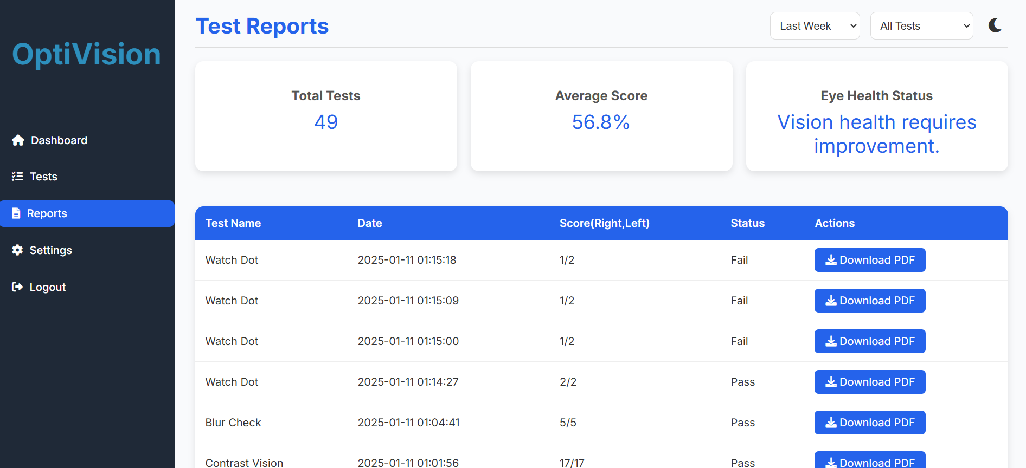

This is the **Test Reports** page of the OptiVision application, where you can review your test history and performance. At the top, you can see key metrics like **Total Tests**, **Average Score**, and **Eye Health Status** for a quick summary of your progress. Below, a detailed table lists individual test results, including the test name, date, score, status (pass or fail), and an option to **Download PDF** reports for each test. Filters at the top-right allow you to sort tests by date or type, making it easy to track and analyze your vision health over time.



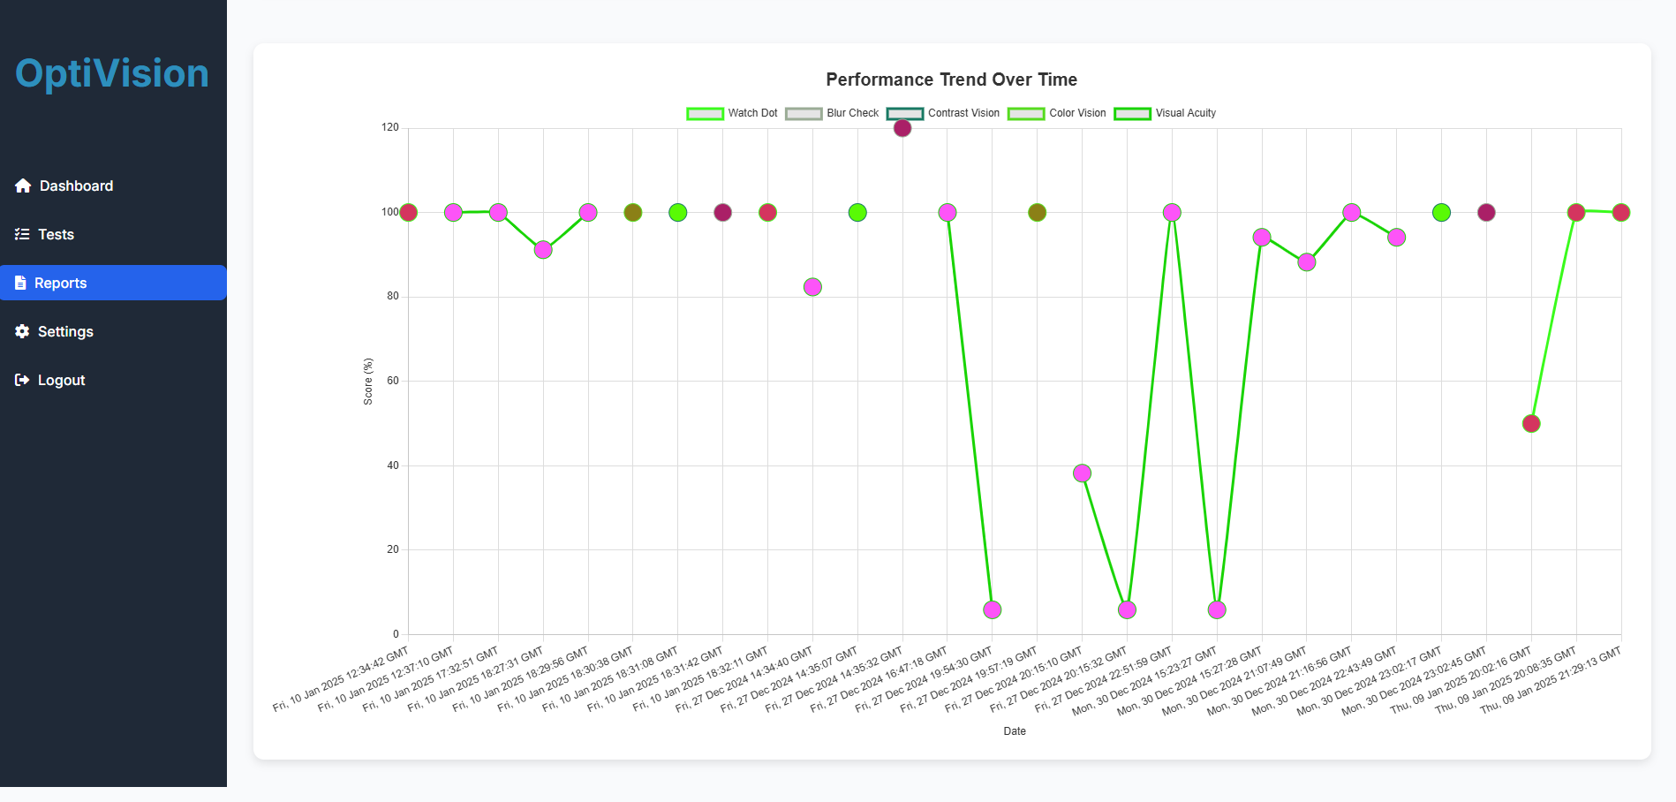By scrolling down, you can view the Performance Trend Over Time chart, which illustrates your scores across various vision tests over specific dates. Each point represents a test result, categorized by type (e.g., Watch Dot, Blur Check, Contrast Vision) and color-coded for easy identification. This chart helps you monitor your progress and identify patterns, enabling you to focus on areas where improvement is needed.



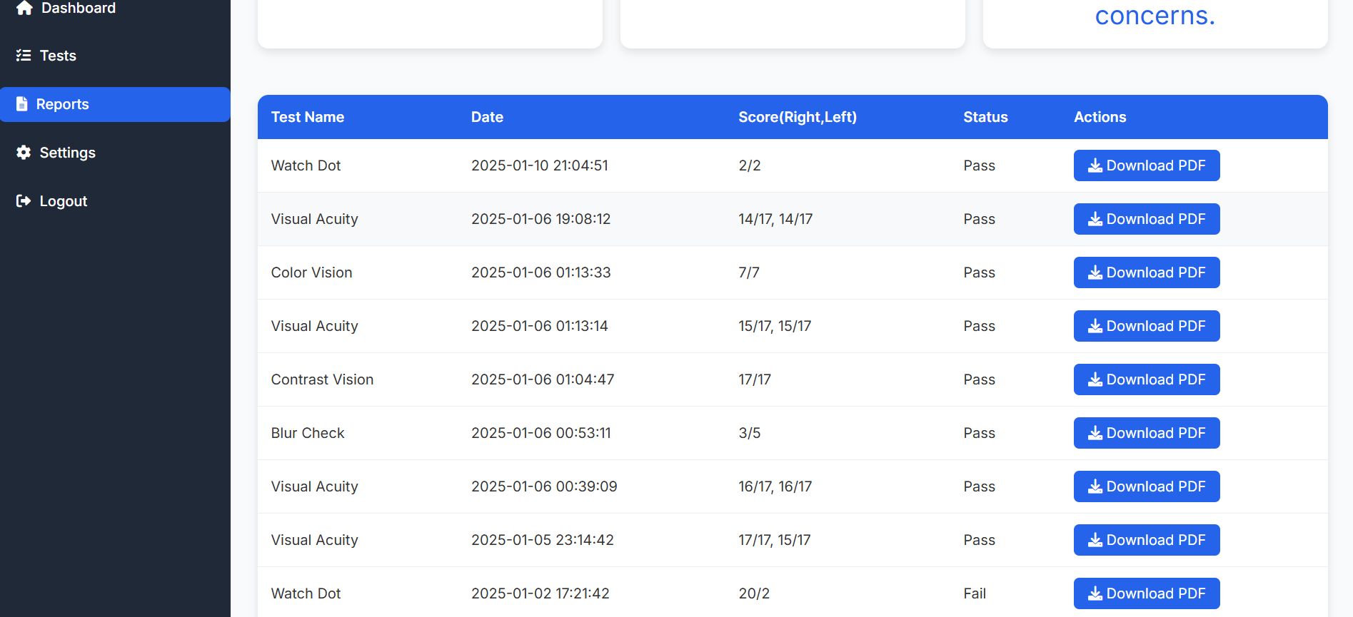

This is a download PDF button, where you can get a PDF report about the selected test.

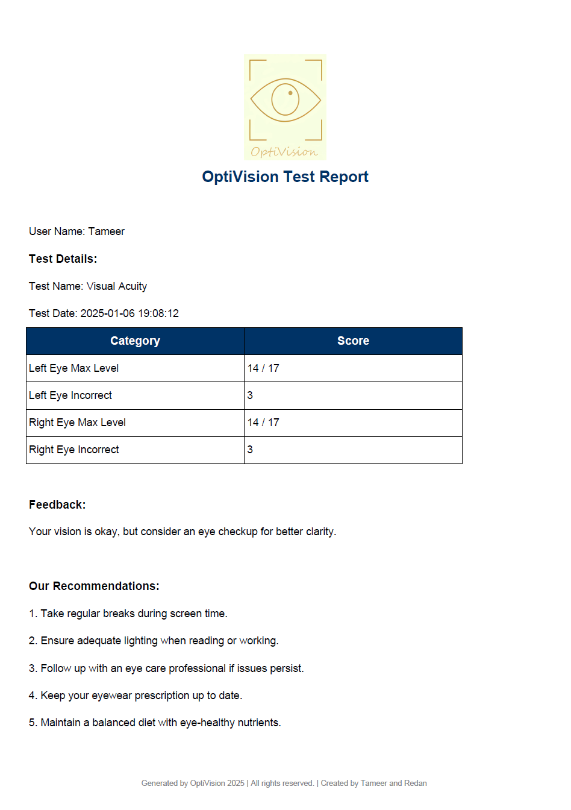

This is a sample OptiVision Test Report generated after completing a vision test, The report is designed to offer a clear, concise overview of your results and helpful guidance for future actions.

* + **Settings:**

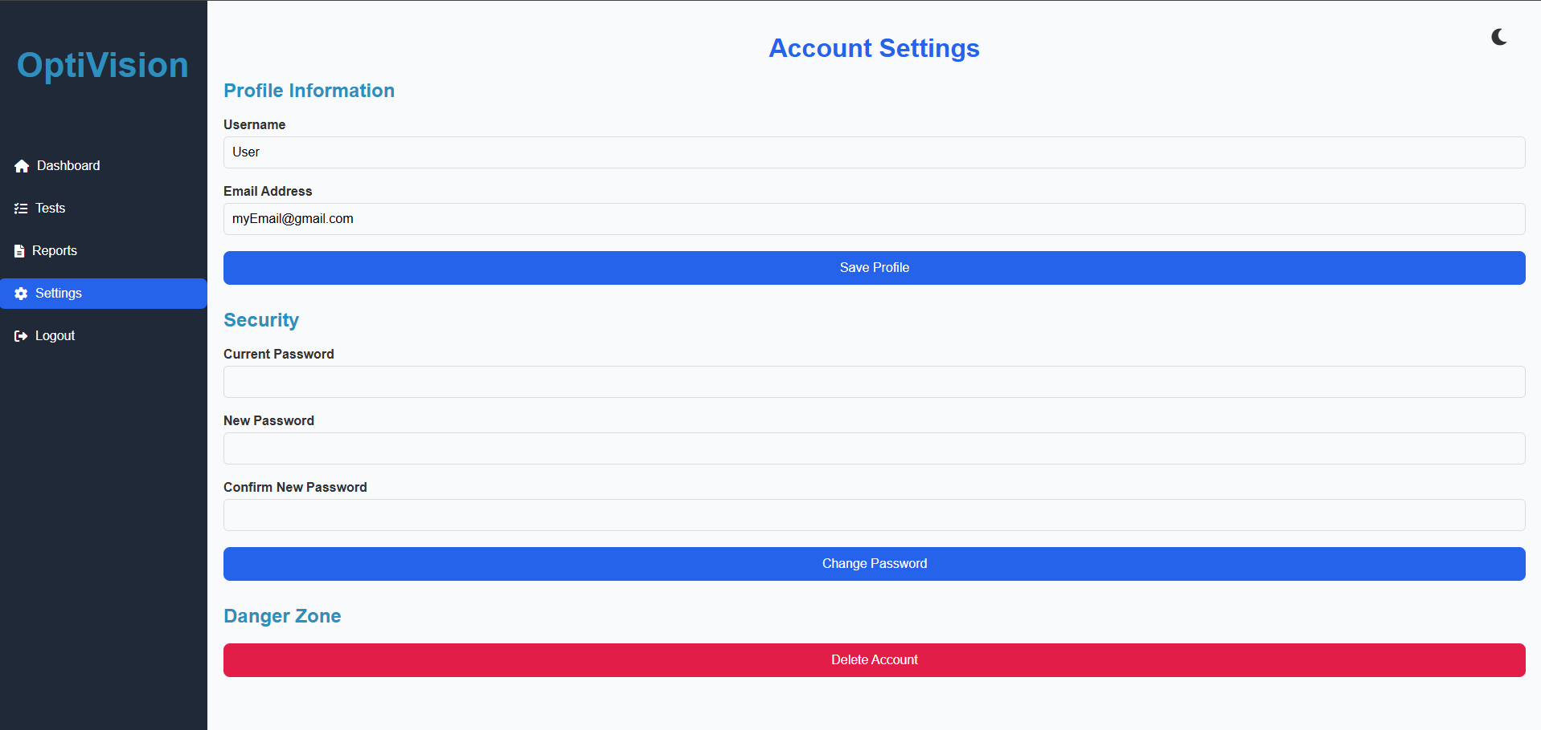

This is the Account Settings page of the OptiVision application, where you can manage your profile and account security.

Profile Information: Update your username and email address, then click **Save Profile** to save changes.

Security: Change your password by entering your current password, new password, and confirming the new password. Click **Change Password** to apply the update.

Danger Zone: Permanently delete your account by clicking **Delete Account**.

* + **Logout:**



By clicking on "Logout", you will be rendered back to "Login" page.

* **Visual Acuity Test:**



By clicking on "Start Test", you will be rendered to "Visual Acuity Test" page.

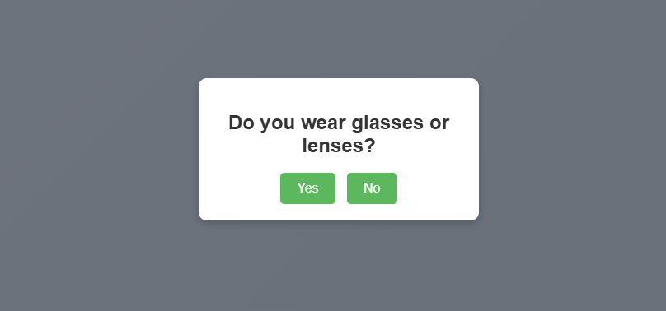

After clicking on "Start Test" you will be asked if you wear glasses or not.

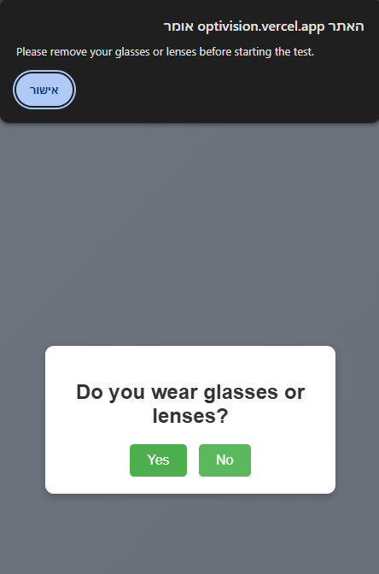

After clicking on "Yes" you will be asked to remove your glasses or lenses before starting the test.

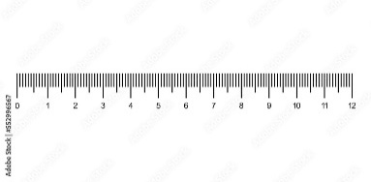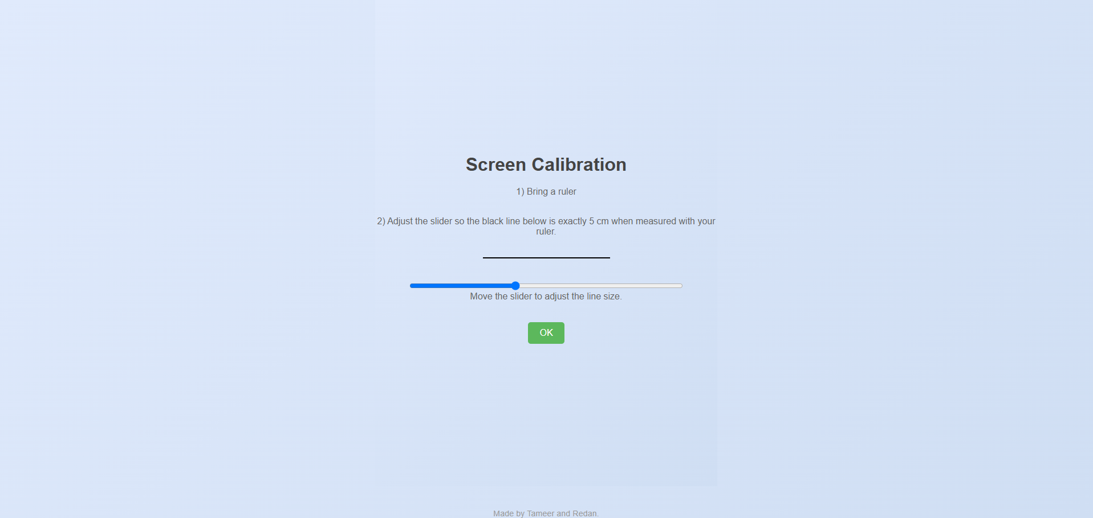

This is the **Screen Calibration** page. It guides you to calibrate your screen for accurate test results:

1. **Bring a ruler**: Ensure you have a physical ruler on hand.
2. **Adjust the slider**: Move the slider so that the black line displayed matches exactly 5 cm when measured with your ruler as in the picture above.

Once calibrated, click **OK** to proceed. This step ensures that the test visuals are displayed at the correct scale, improving the accuracy of your results.

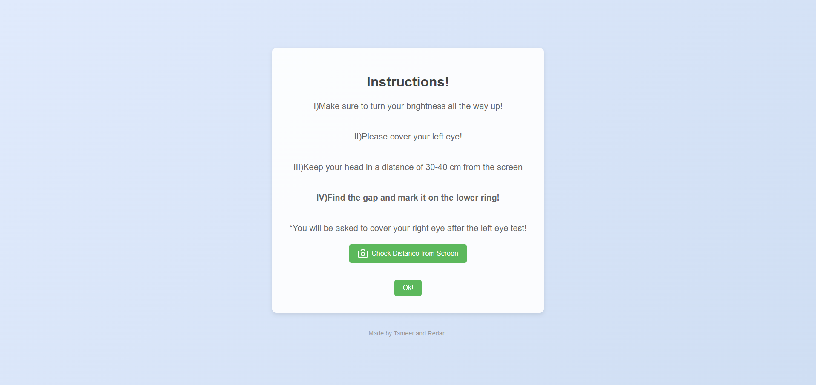

After clicking on "ok", you will see the instructions before starting the test.

Use the **Check Distance from Screen** button for assistance if needed, and click **OK** to proceed when ready.

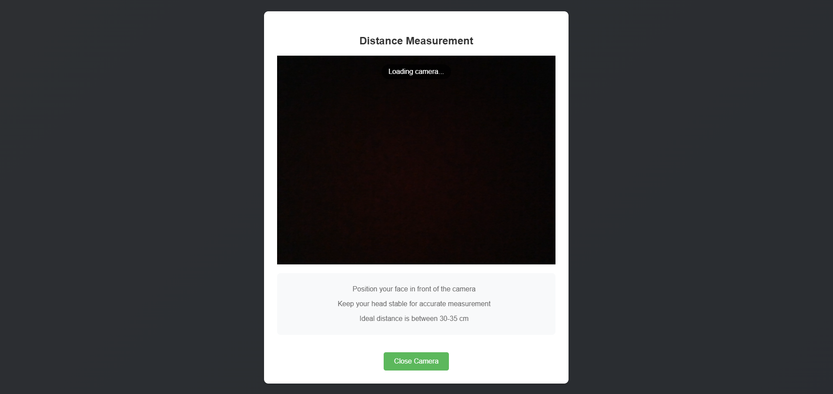

This is the **Distance Measurement** feature of the OptiVision application, designed to help you maintain the correct distance for accurate test results.

* **Position your face** in front of the camera.
* **Keep your head stable** for precise measurement.
* Ensure your face remains at the ideal distance of **30–35 cm** throughout the entire test for optimal accuracy.

Once you're properly positioned, you can proceed with the test. To exit this feature, click **Close Camera**.

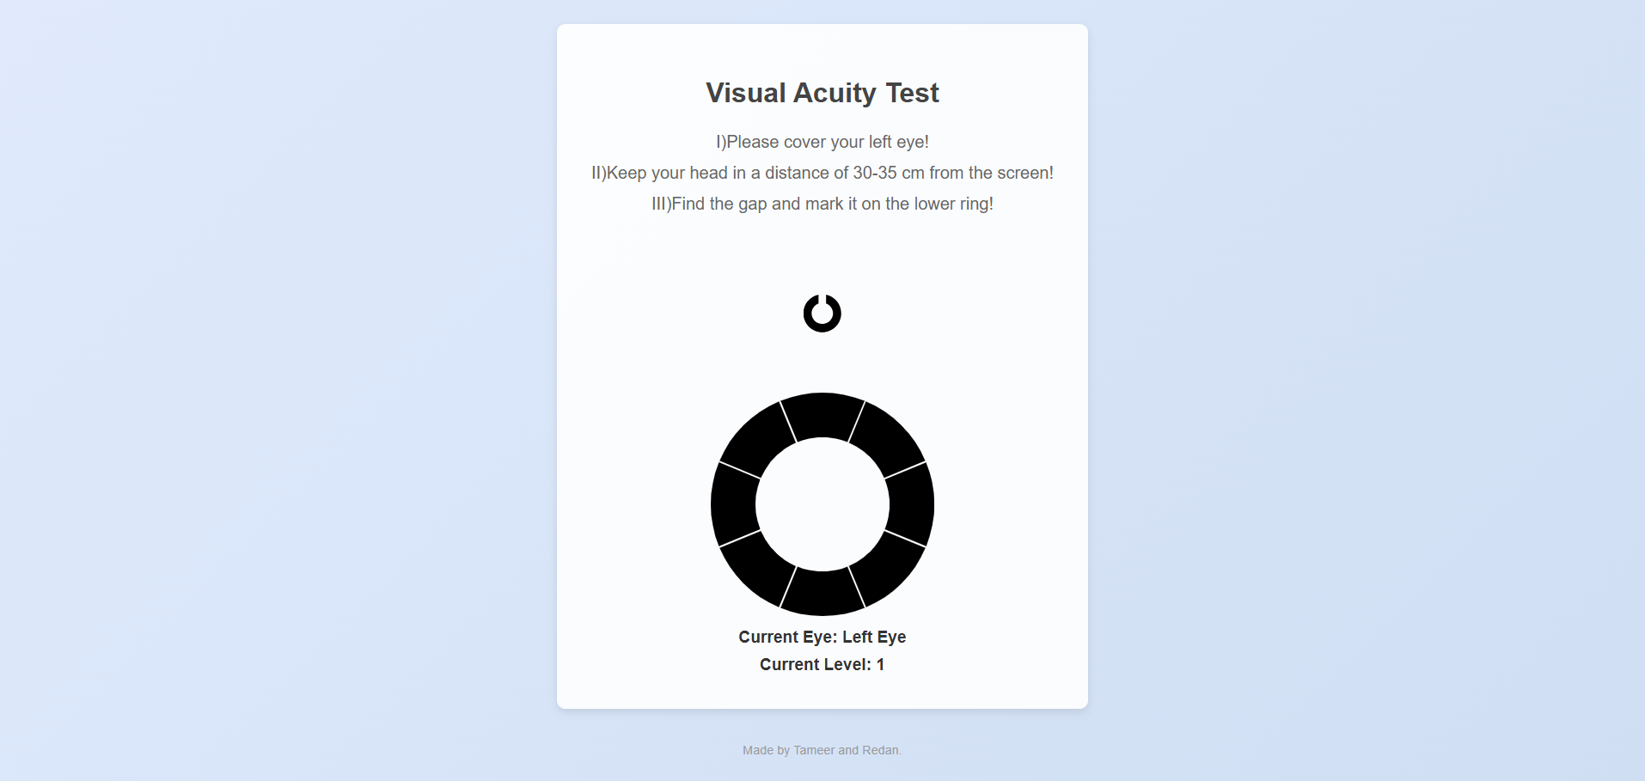

This is the **Visual Acuity Test** interface in the OptiVision application. Follow these instructions to ensure accurate results:

1. **Cover your left eye** for the first part of the test.
2. **Maintain a distance of 30–35 cm** from the screen throughout the test.
3. **Identify the gap** in the lower ring and mark it accordingly.

The current eye being tested and level of difficulty are displayed below the ring. After completing the left eye test, you will proceed to test the right eye. Ensure you maintain the correct distance for accurate assessment.

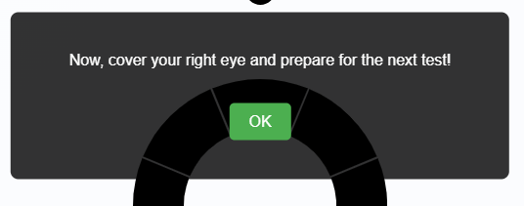

When you complete the left eye test, a pop up message will appear on your screen with a message "**Now, cover your right eye and prepare for the next test!**".

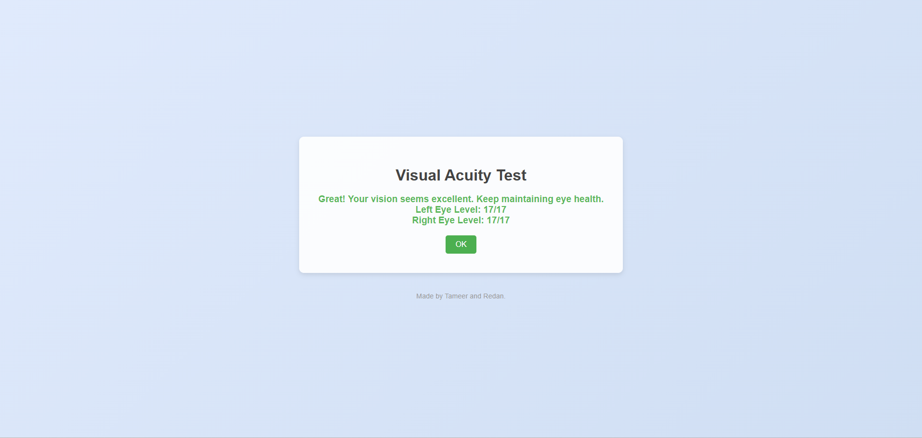

This is the **Visual Acuity Test** results screen. It provides feedback on your test performance.

Click **OK** to complete and proceed to the next step.

* **Color Vision Test:**

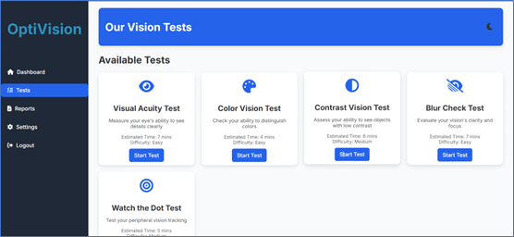

By clicking on "Start Test", you will be rendered to "Color Vision Test" page.

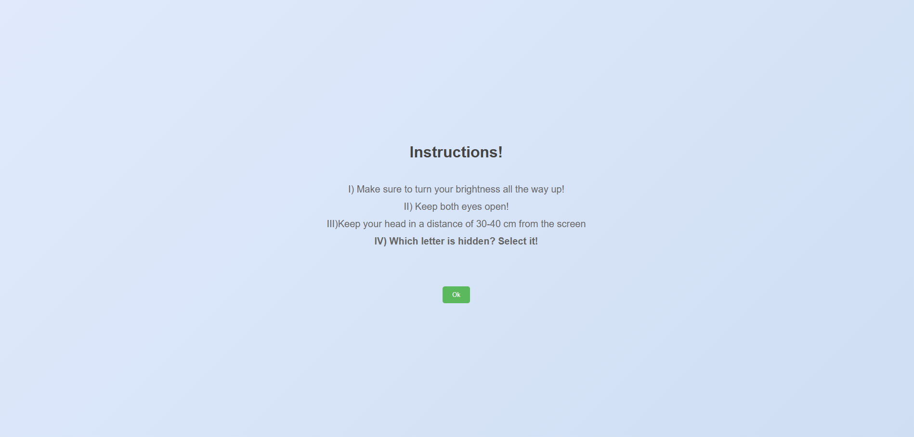

After clicking on "ok", you will see the instructions before starting the test.

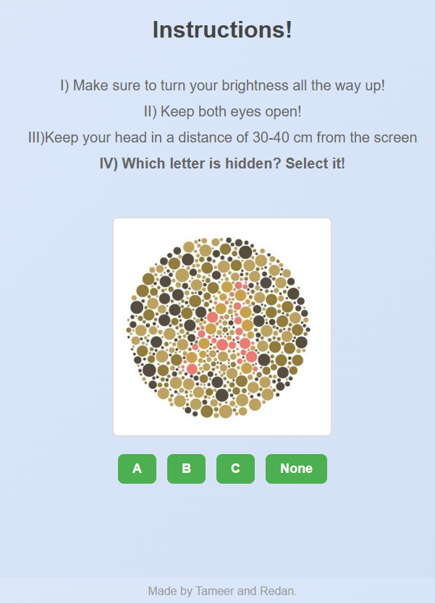

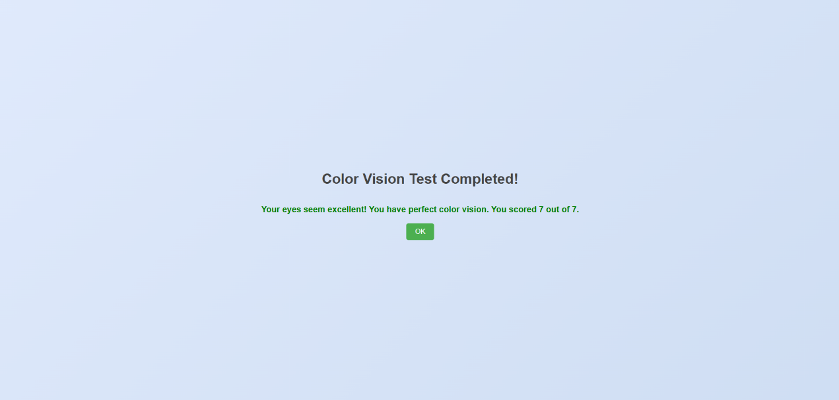Select the letter you can see. If you can't see any letter, click "None."

This is the **Color Vision Test Completion** screen.

Click **OK** to confirm and proceed to the next step or return to the dashboard.

* **Contrast Vision Test:**

 

By clicking on "Start Test", you will be rendered to "Contrast Vision Test" page.

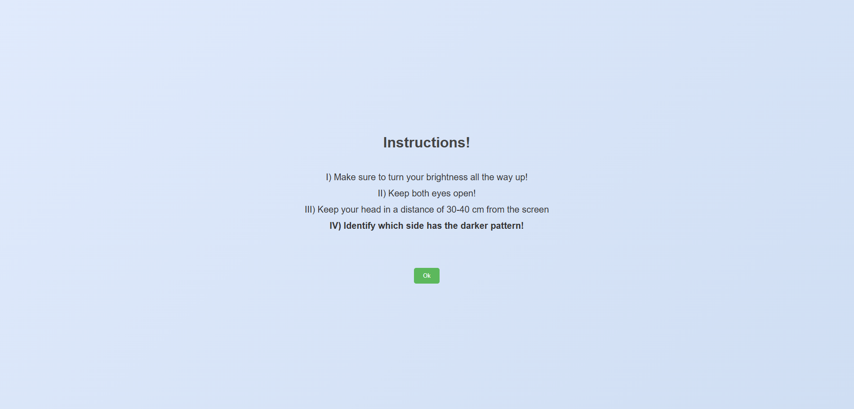

After clicking on "ok", you will see the instructions before starting the test.

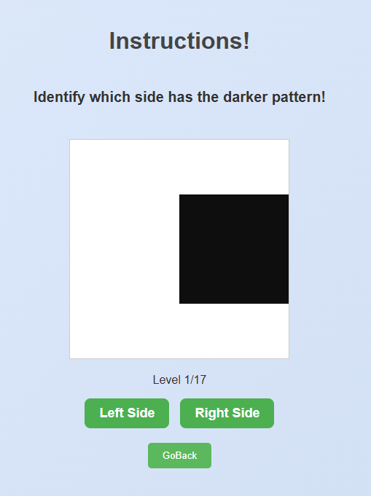

This is the **Contrast Sensitivity Test** interface in the OptiVision application. Follow these instructions:

* Identify which side of the square (left or right) has the darker pattern.
* Click **Left Side** or **Right Side** based on your observation.
* If unsure or want to exit, click **Go Back**.

Your progress is displayed as the current level (e.g., Level 1/17). Continue until the test is complete.

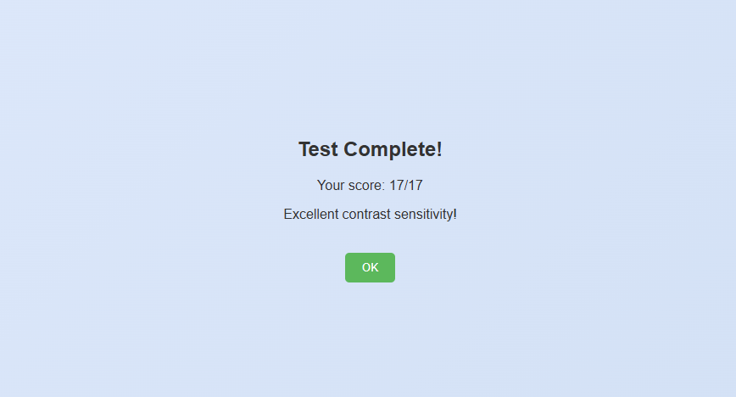

After finishing the test, you will see the results page.

* **Blur Vision Test:**

 

By clicking on "Start Test", you will be rendered to "Blur Check Test" page.

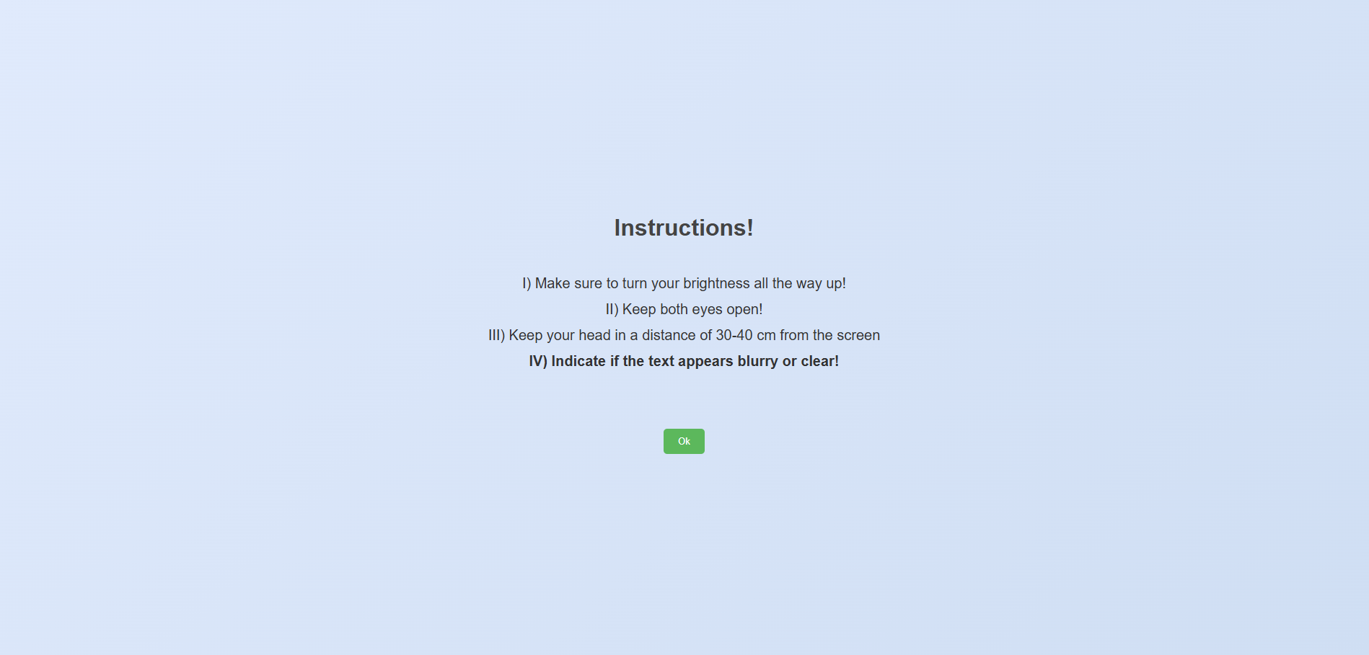

After clicking on "ok", you will see the instructions before starting the test.

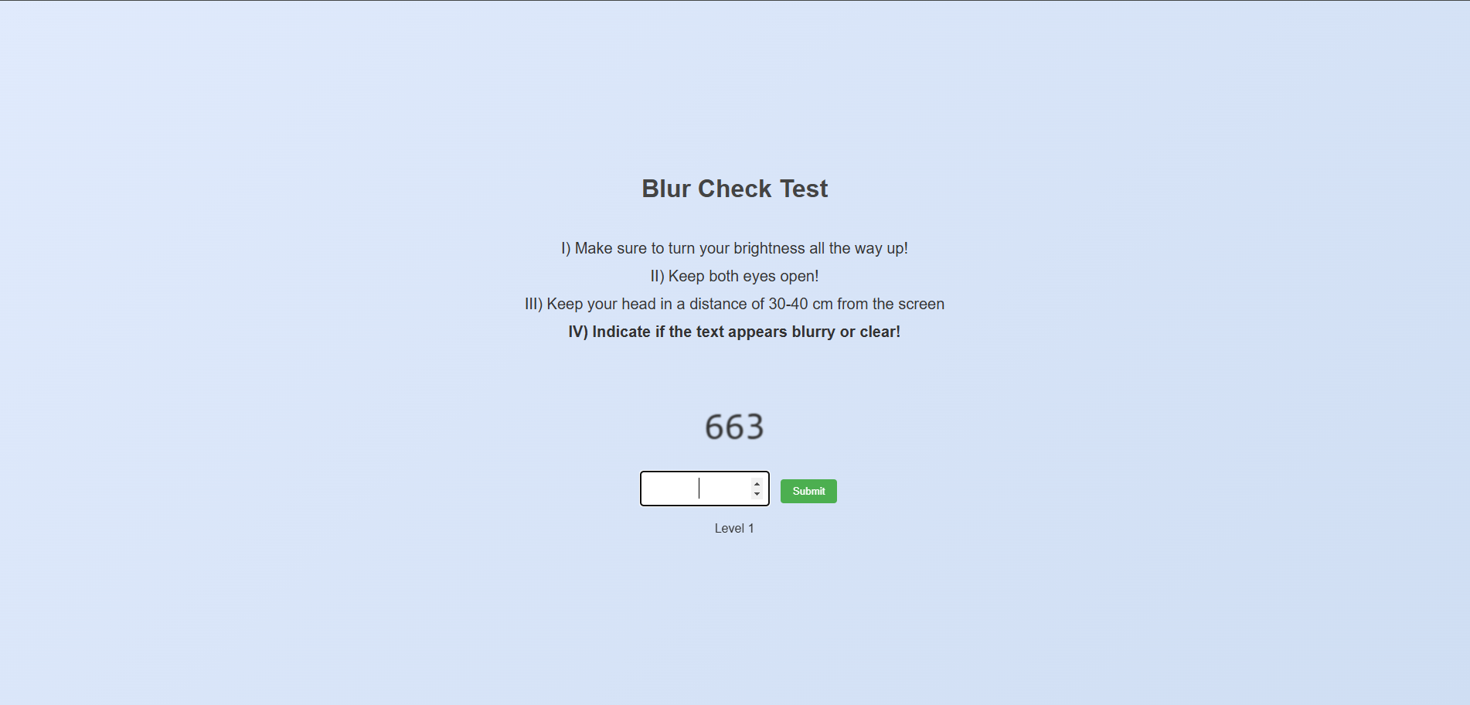

This is the **Blur Check Test** interface in the OptiVision application. Follow these instructions to complete the test:

1. **Turn your brightness all the way up** for clear visibility.
2. **Keep both eyes open** during the test.
3. **Maintain a distance of 30–40 cm** from the screen for accurate results.
4. **Indicate if the displayed text appears blurry or clear** by typing the number shown and clicking **Submit**.

Your current level is displayed below the input box (e.g., Level 1). Continue until the test is complete.

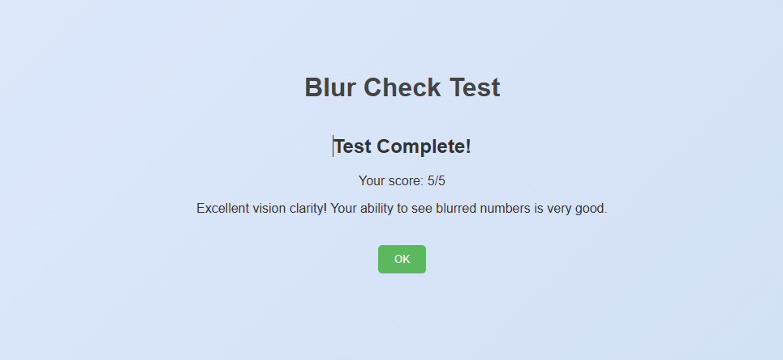

This is the **Blur Check Test Completion** screen. Click **OK** to confirm and return to the dashboard.

* **Watch The Dot Test:**

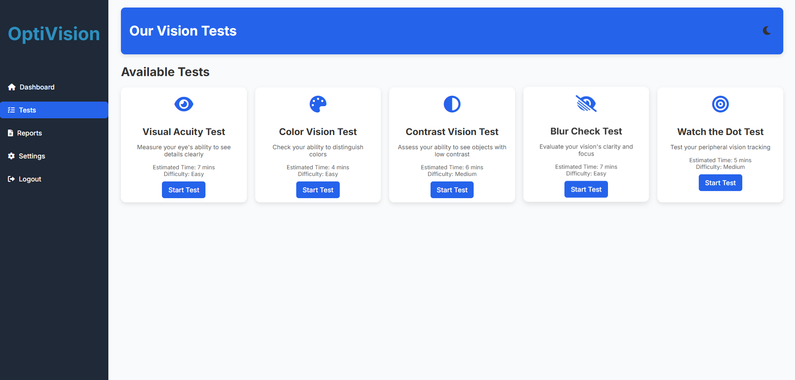

By clicking on "Start Test", you will be rendered to "Watch The Dot Test" page.

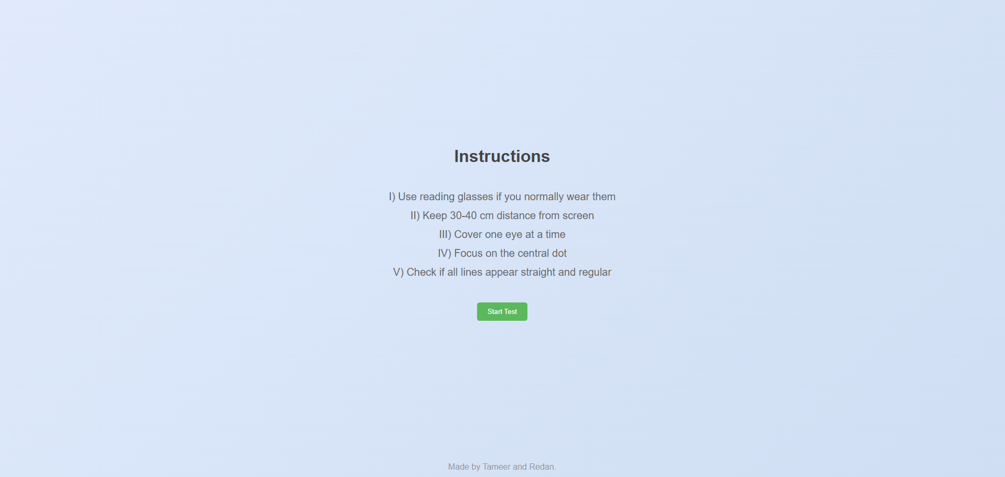

After clicking on "ok", you will see the instructions before starting the test.

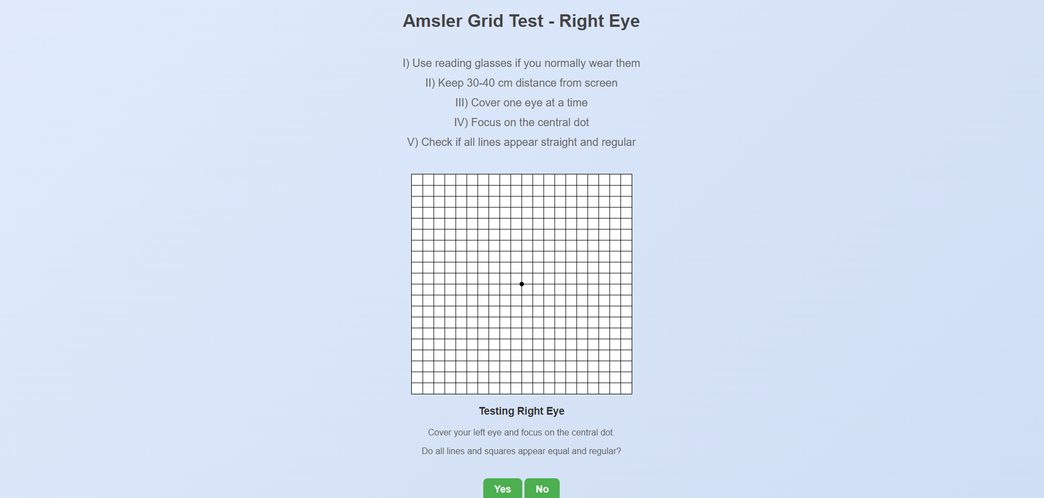

This is the **Amsler Grid Test** interface for the right eye in the OptiVision application. Follow these steps to complete the test:

1. **Use reading glasses** if you normally wear them.
2. **Maintain a distance of 30–40 cm** from the screen.
3. **Cover one eye at a time**—start by covering your left eye for this test.
4. **Focus on the central dot** in the grid.
5. **Check if all lines appear straight and squares regular**.

Respond with **Yes** if the lines and squares look normal, or **No** if any distortions or irregularities are observed.

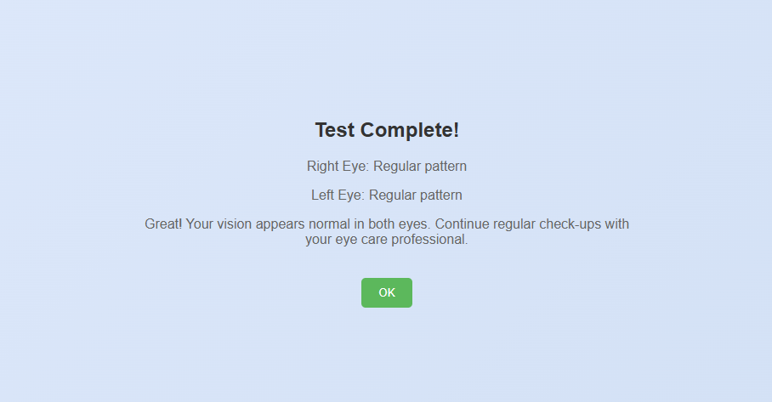

This screen displays the **Test Completion Summary** for the test. Click **OK** to confirm and return to the dashboard.



# Developer Documentation

**24-2-D-23**

Tameer Amer 322836388

Redan Ganim 209003474

Mentor: Dr. Natali Levi

Table of Contents

1. Introduction 3

2. System Requirements and Installation Guide 4

System Requirements 4

Installation Guide 5

3. System Architecture Overview 6

3.1 High-Level Architecture 6

3.2 System Components 7

3.3 System Flow 11

3.3.1 User Authentication 11

3.3.2 Test Selection and Setup 11

3.3.3 Vision Test Execution 11

3.3.4 Data Processing and Storage 26

3.3.5 Result Presentation 27

3.4 Technical Implementation 28

3.5 Security Measures 28

4. Code Review 29

4.1 app.py File 29

4.2 DB_connection.py File 30

4.3 Static Directory 32

4.4 Templates Directory 33

4.5 JavaScript Files Review 34

4.5.1 VisualAcuityTest.js 34

4.5.2 ColorVisionTest.js 35

4.5.3 ContrastVisionTest.js 36

4.5.4 BlurCheckTest.js 36

4.5.5 WatchTheDotTest.js 37

5. Deployment 38

5.1 Overview 38

5.2 Vercel Configuration 38

5.3 Deployment Process 39

6. Technical Documentation 40

6.1 Database Relationship Diagram 40

6.2 API Documentation 40

6.3 Error Handling 42

6.3.1 Database Errors 42

6.3.2 Test Processing Errors 42

6.4 Troubleshooting Guide 43

6.4.1 Authentication Issues 43

6.4.2 Test Execution Issues 43

6.4.3 Database Connection Issues 44

6.4.4 Performance Issues 44

1. Introduction

OptiVision is a comprehensive web-based vision testing platform designed to provide accessible and accurate vision assessments. The platform offers five specialized vision tests, each targeting different aspects of visual function:

1. **Visual Acuity Test**: Measures the sharpness of vision
2. **Color Vision Test**: Evaluates color perception and identification
3. **Contrast Vision Test**: Assesses ability to distinguish contrast differences
4. **Blur Check Test**: Tests vision clarity at different blur levels
5. **Watch Dot Test**: Evaluates focus and pattern recognition

Key Features:

**User Interface**

* Simple navigation between tests
* User-friendly test interfaces
* Responsive design for various devices
* Dark/Light mode support

**Testing Capabilities**

* Individual eye testing (left/right)
* Progressive difficulty levels
* Real-time feedback
* Comprehensive result analysis

**Technical Features**

* Secure user authentication
* Database result storage
* PDF report generation
* Email integration
* Cross-browser compatibility

Dashboard:

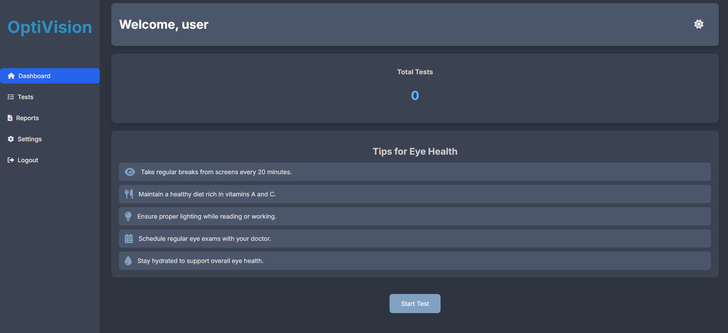

2. System Requirements and Installation Guide

System Requirements

Frontend:

• Modern web browser (Chrome, Firefox, Safari, Edge)

• JavaScript enabled

• Webcam access for acuity vision tests

Backend:

• Python 3.x

• MySQL Server

• Required Python packages (included requirements.txt)

requirements.txt:

flask

mysql-connector-python

bcrypt

fpdf

Installation Guide

1. Clone Repository

git clone https://github.com/TameerAmer/Capstone-Project

cd optivision

2. Install Dependencies

Terminal:pip install -r requirements.txt

3. Database Setup

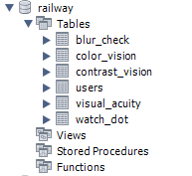

4. Run Application

Python: app.py

3. System Architecture Overview

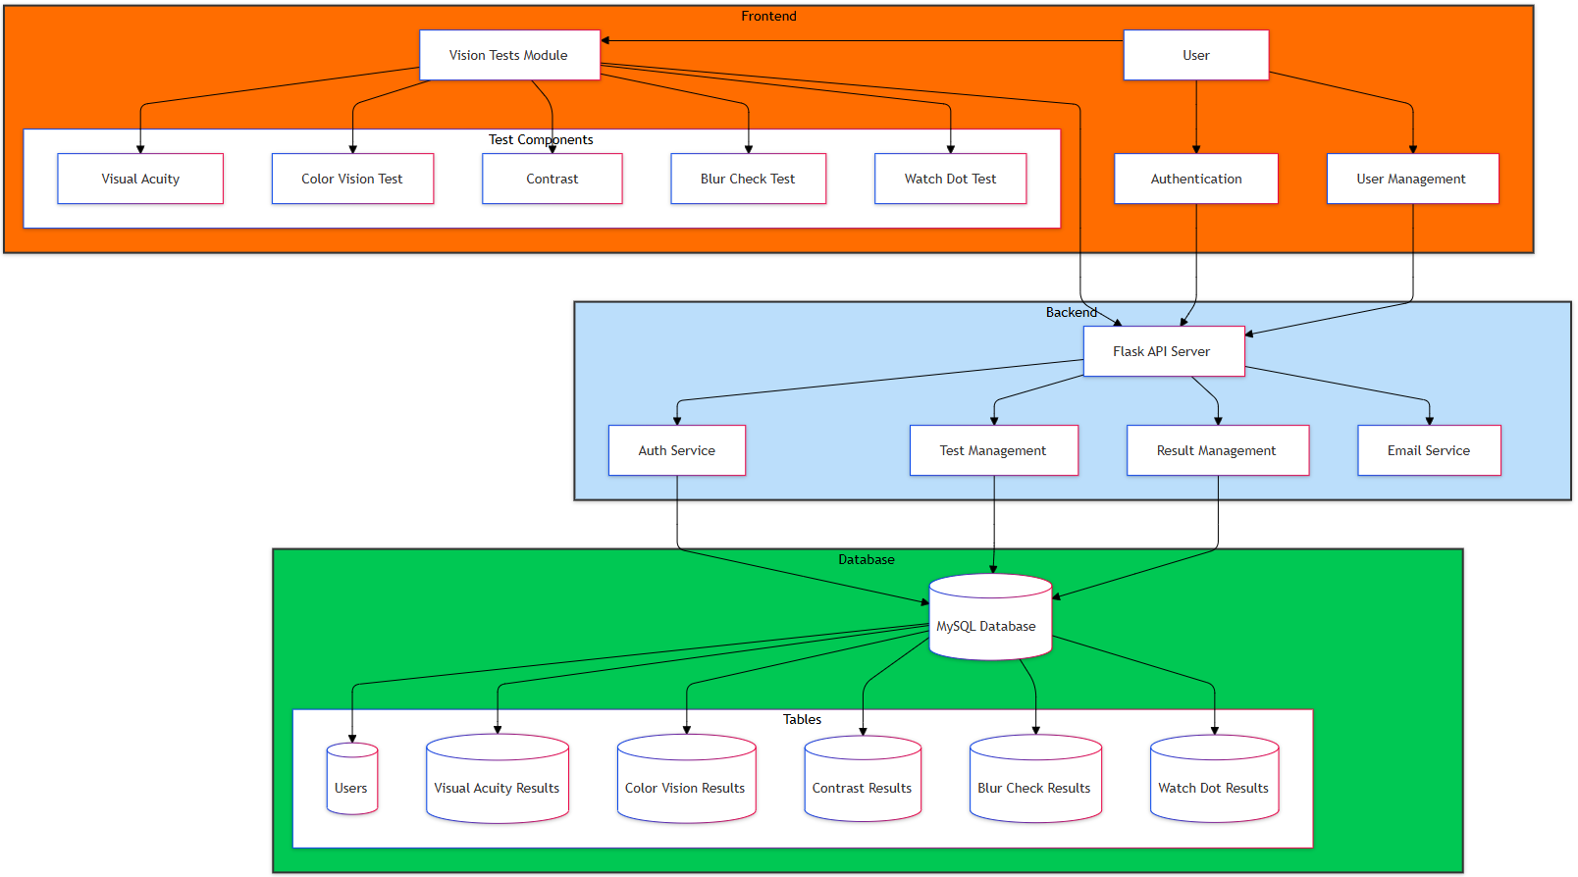

3.1 High-Level Architecture

OptiVision follows a three-tier architecture:

1. **Frontend Layer**: HTML, CSS, JavaScript
2. **Backend Layer**: Flask (Python)
3. **Database Layer**: MySQL

**Core Components Diagram**

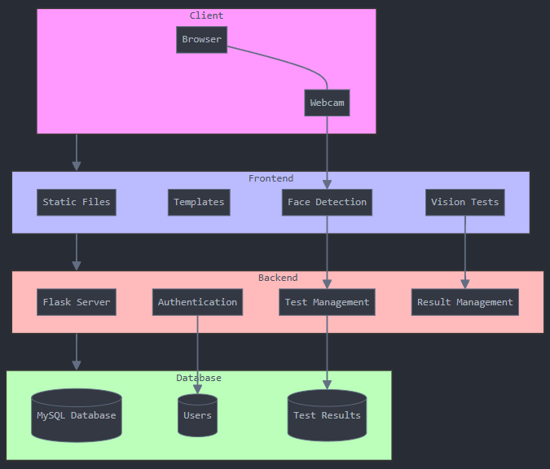

3.2 System Components

**1. Frontend**

Built with HTML, CSS, and JavaScript, the frontend handles:

* User interactions and test displays
* Static files (images, face detection models, css and js)
* Test execution logic
* Real-time distance calibration
* Result visualization

The frontend components are organized in:

**2. Backend (Flask Server)**

A Flask-based server that:

* Processes test data
* Manages user sessions
* Interacts with the MySQL database
* Handles authentication
* Generates PDF reports

**. Database (MySQL)**

Stores:

* User data
* Test results
* Authentication information

Database collections include:

Users Table:

* user_id (Primary Key)
* name
* email
* password (hashed)
* settings

**4. Face Detection System**

Implements webcam-based distance calibration using:

* Face landmark detection
* Real-time distance calculation
* 5. User Interfaces 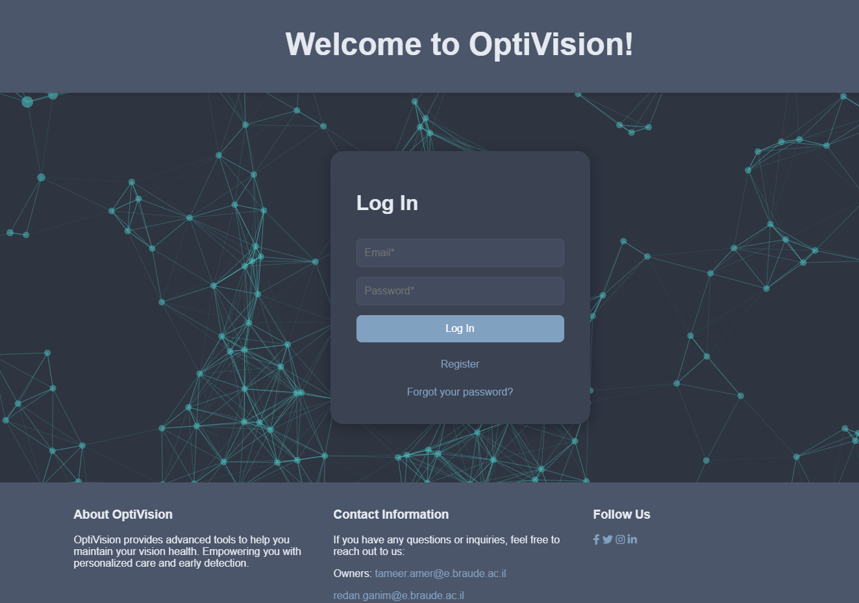

The login interface includes:

* Clean, minimalist design with a dark theme
* Email and password input fields with validation
* "Remember me" functionality
* Password recovery link
* Registration link for new users
* Error message display for invalid credentials

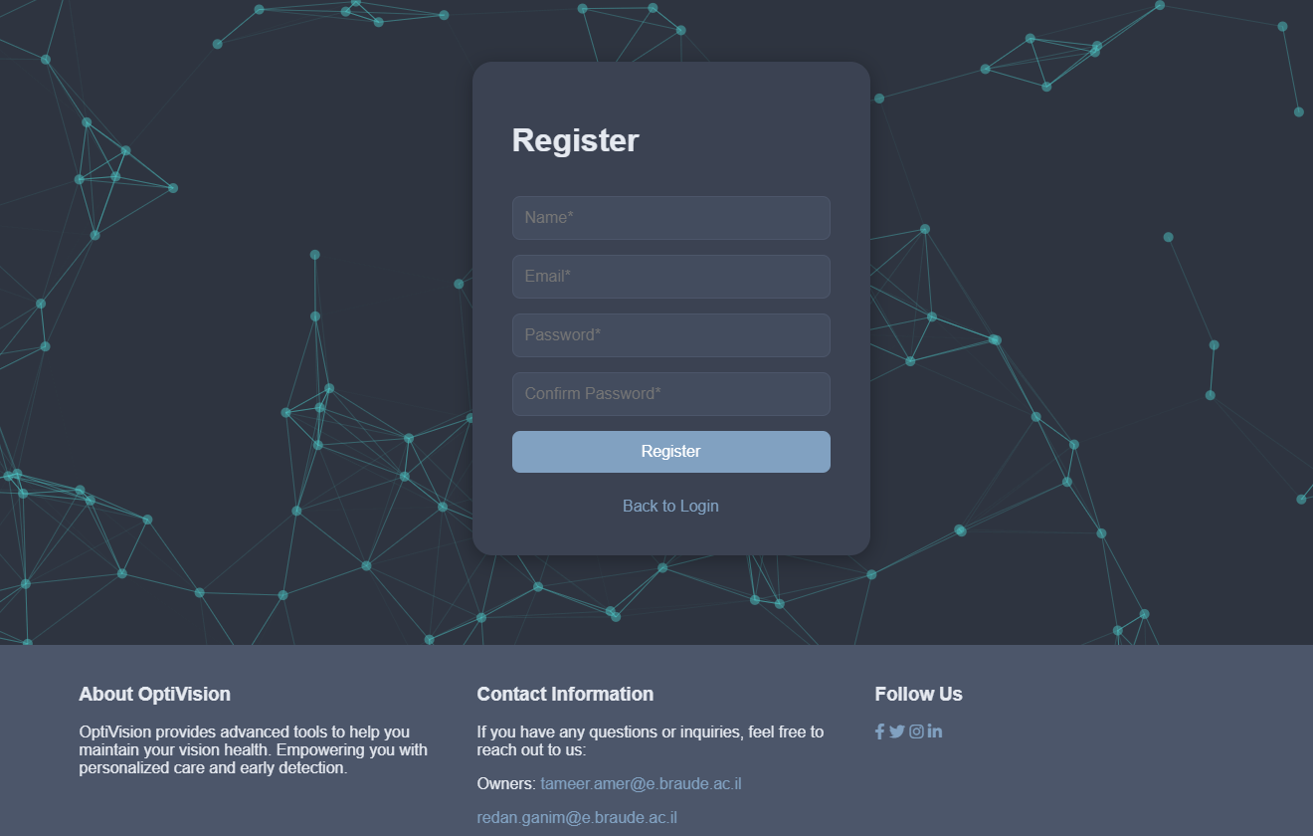

The registration interface contains:

* User-friendly form layout
* Required fields:
  + Full Name
  + Email address
  + Password
  + Password confirmation
* Password strength requirements
* Email validation
* Success/Error message display

3.3 System Flow

OptiVision operates through a structured sequence designed to guide users through vision testing:

3.3.1 User Authentication

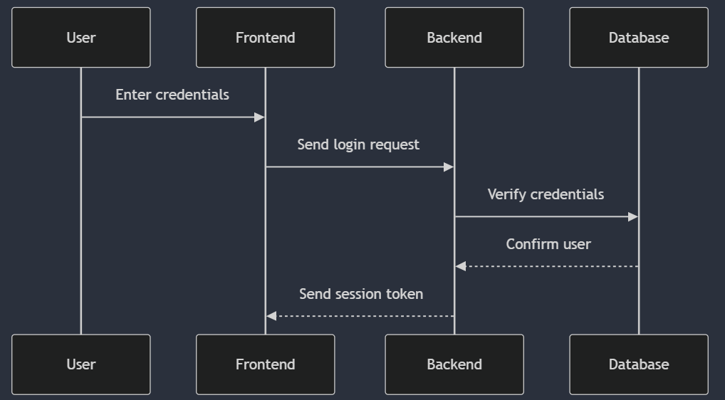

3.3.2 Test Selection and Setup

When a user selects a test:

1. Frontend loads test interface
2. Webcam calibration initiates (if required)
3. Test instructions are displayed
4. System performs environment checks

3.3.3 Vision Test Execution

**Vision Test Execution Flows**

**1. Visual Acuity Test Flow**

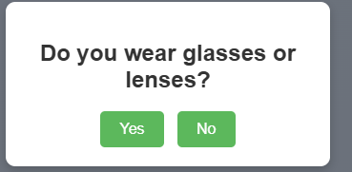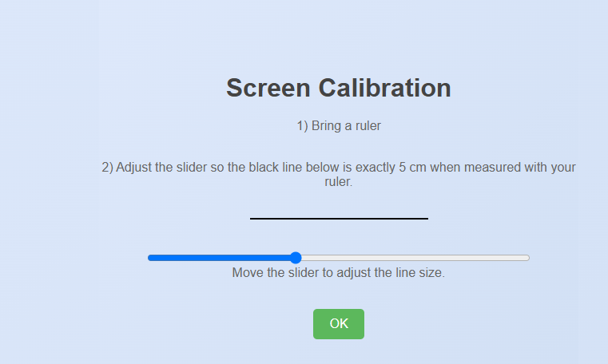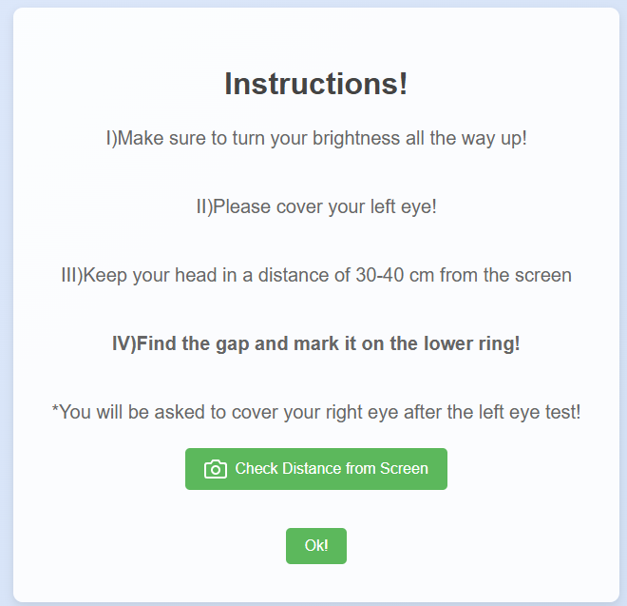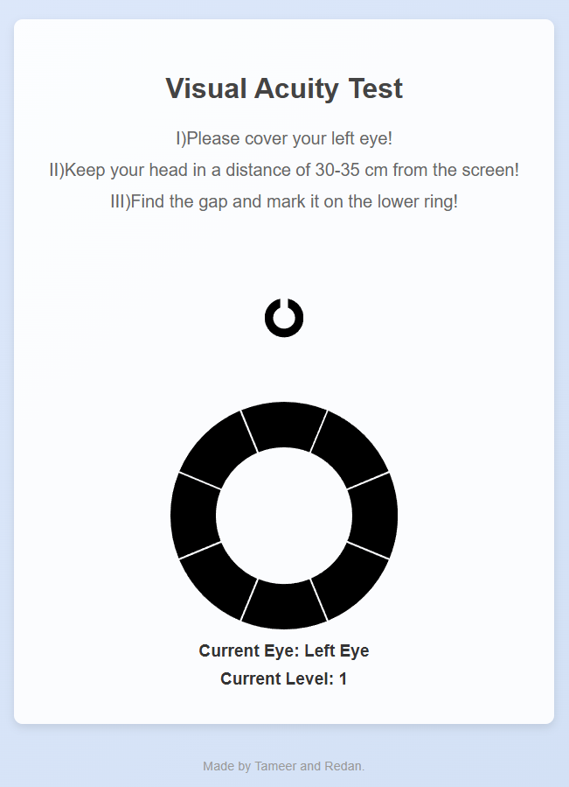

**1.1 Distance Calibration**

* Webcam activates
* Face detection models load
* System confirms proper distance (30-40cm)
* Distance feedback provided to user

**1.2 Test Execution**

* Separate testing for each eye (left/right)
* Progressive difficulty levels (17 levels)
* C-shaped pattern display with rotation
* Real-time response recording
* Immediate feedback after each response

**1.3 Result Processing**

* Score calculation for each eye
* Combined score generation
* Feedback based on performance
* Database storage of results
* PDF report generation

**2. Color Vision Test Flow**

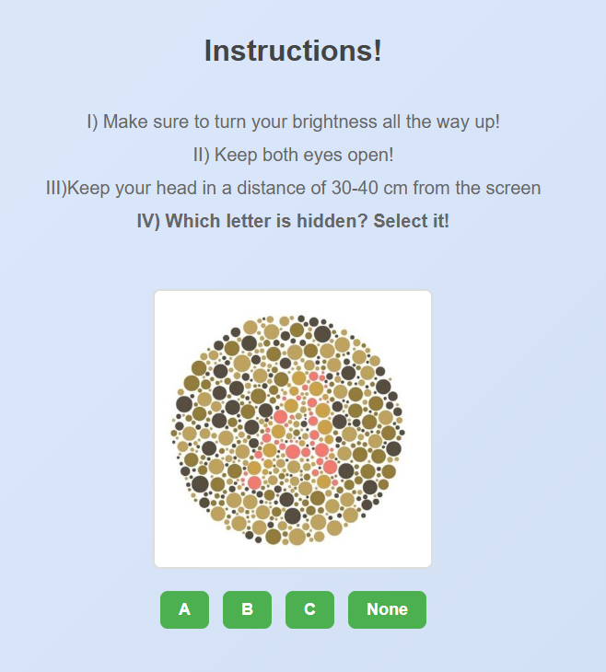

**2.1 Pattern Display**

* Instructions presentation
* Color patterns load (7 patterns total)
* Pattern size and contrast verification
* Display calibration check

**2.2 User Response**

* Pattern recognition choices
* Multiple choice options display
* Answer recording per pattern
* Progress tracking

**2.3 Analysis**

* Score calculation (correct vs incorrect)
* Color vision assessment
* Colorblindness type identification
* Result storage in database
* Detailed feedback generation

**3. Contrast Vision Test Flow**

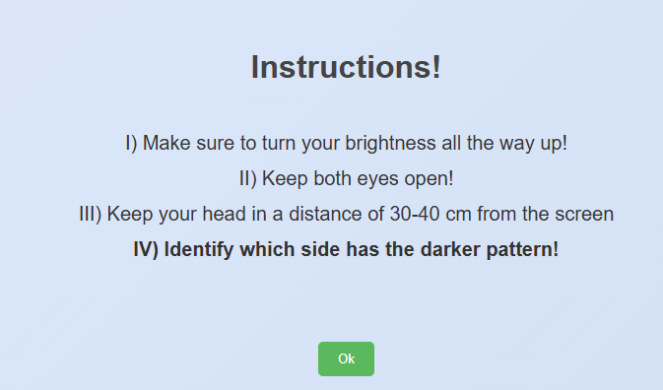 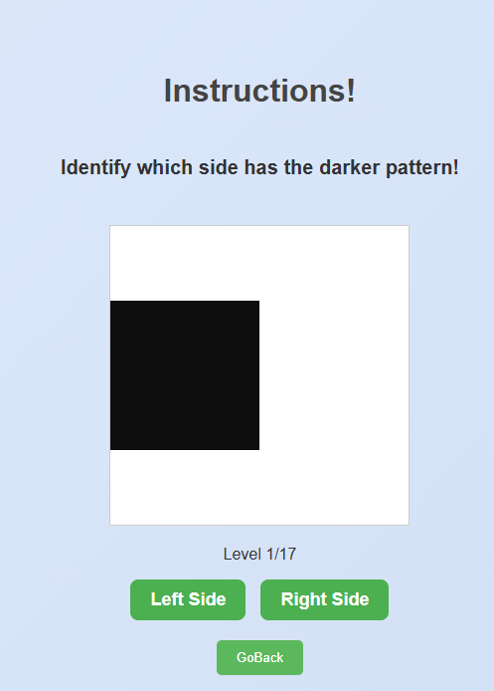

**3.1 Test Setup**

* Screen brightness check
* Initial contrast calibration
* Instructions display
* Pattern generation initialization

**3.2 Test Execution**

* Progressive contrast levels (17 levels)
* Side-by-side pattern comparison
* User selection recording
* Adaptive difficulty adjustment

**3.3 Result Analysis**

* Contrast sensitivity scoring
* Threshold determination
* Performance curve generation
* Database result storage
* Recommendations generation

**4. Blur Check Test Flow**

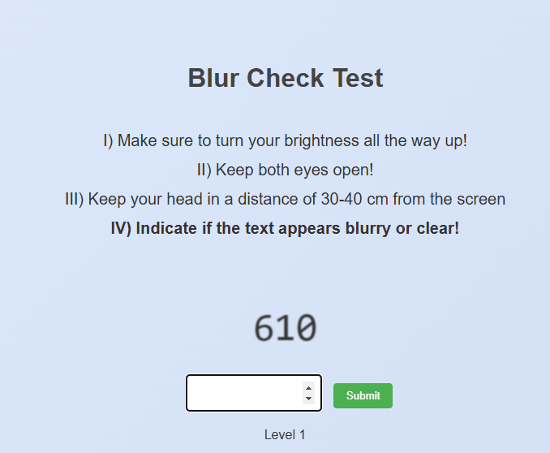

**4.1 Initial Setup**

* Screen clarity verification
* Number generation system initialization
* Instructions presentation
* Font size calibration

**4.2 Test Process**

* Random number display (3 digits)
* Progressive blur application (5 levels)
* User input collection
* Answer verification
* Immediate feedback

**4.3 Results Processing**

* Accuracy calculation
* Blur tolerance assessment
* Score compilation
* Database storage
* Performance feedback generation

**5. Watch Dot Test Flow**

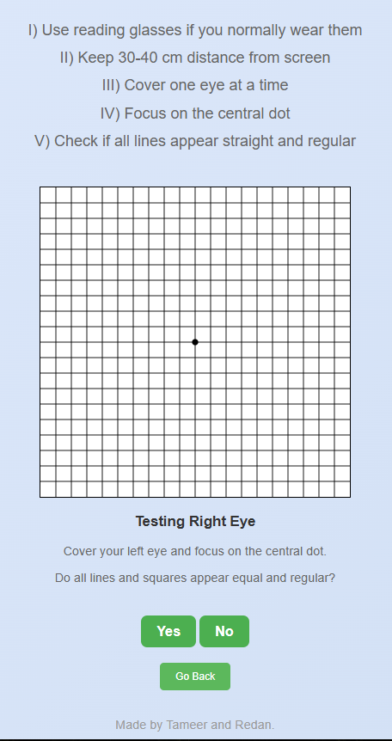

**5.1 Test Preparation**

* Grid pattern generation
* Central dot positioning
* Instructions display
* Eye coverage guidance

**5.2 Test Implementation**

* Separate eye testing
* Grid pattern presentation
* Pattern irregularity check
* User response collection
* Response time tracking

**5.3 Result Compilation**

* Pattern recognition analysis
* Visual field assessment
* Score calculation
* Database entry creation
* Feedback formulation

**Common Elements Across Tests**

**Data Collection**

* User identification
* Test timestamp
* Environmental conditions
* Device information
* Browser details

**Result Storage**

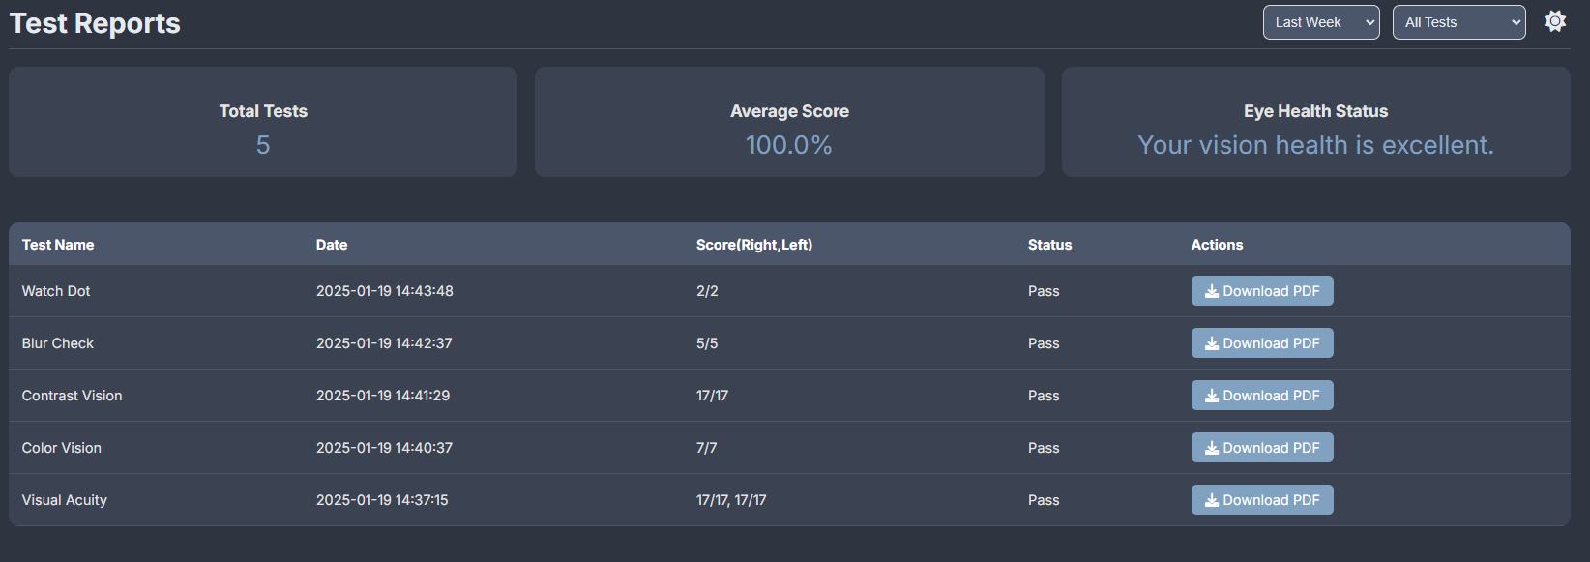

* Test-specific scores
* User performance metrics
* Time stamps
* Environmental data
* System configuration

**Report Generation**

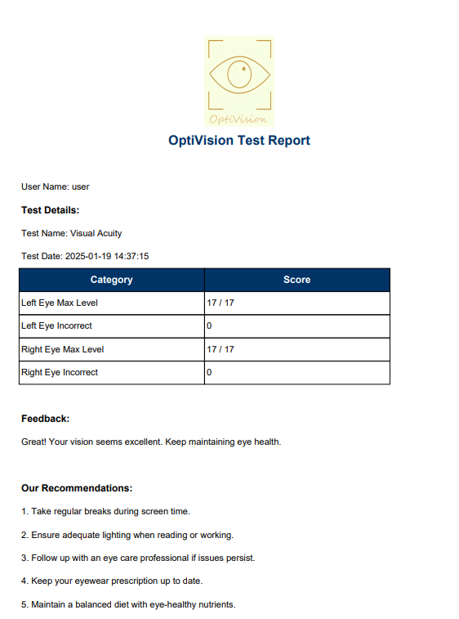

* Individual test results
* Combined analysis
* Recommendations
* Historical comparison
* PDF formatting

**Security Measures**

* Data encryption
* User authentication
* Session management
* Privacy protection
* Access control

3.3.4 Data Processing and Storage

Each test result follows this flow:

1. Raw data collection
2. Score calculation
3. Database storage
4. PDF report generation

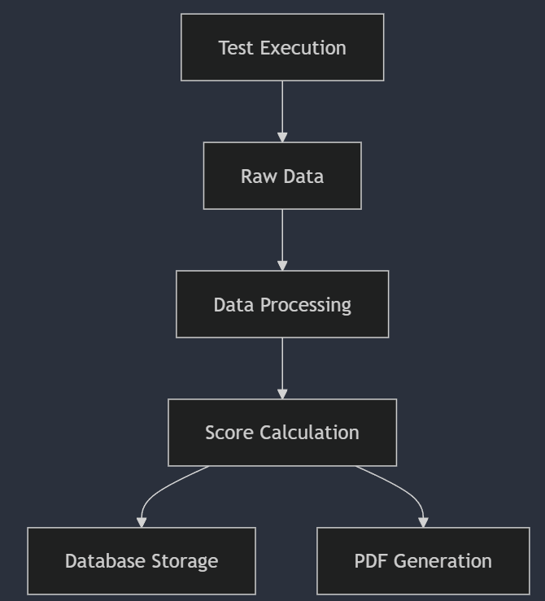

3.3.5 Result Presentation

The system:

1. Retrieves processed results
2. Generates visual representations
3. Creates downloadable reports
4. Stores historical data

3.4 Technical Implementation

Database Operations

def save_test_result(user_id, test_type, results):

    connection = get_connection()

    cursor = connection.cursor()

    query = """INSERT INTO test_results

               (user_id, test_type, results)

               VALUES (%s, %s, %s)"""

    cursor.execute(query, (user_id, test_type, results))

    connection.commit()

**Face Detection Implementation**

async function calculateDistance(faceBox) {

    const FOCAL_LENGTH = 715;

    const FACE_WIDTH = 20;

    const distance = Math.round(

        (FACE_WIDTH * FOCAL_LENGTH) /

        (faceBox.width * CALIBRATION_FACTOR)

    );

    return distance;

}

3.5 Security Measures

1. Authentication:
   * Password hashing
   * Session management
   * Token validation
2. Data Protection:
   * Input sanitization
   * SQL injection prevention
   * XSS protection
3. Privacy:
   * Data encryption
   * Secure connections
   * Access control

4. Code Review

This section provides a comprehensive analysis of the OptiVision codebase. We will examine the functionality of each component, explaining the purpose and implementation of the code, as well as its role within the overall system architecture. Additionally, we will discuss best practices for maintaining the code, ensuring its scalability, and facilitating future enhancements. This review aims to equip developers with a deep understanding of the system's inner workings, enabling them to effectively manage and extend the functionality as needed.

4.1 app.py File

This file serves as the core of the Flask application, containing all the main route definitions and application logic. It acts as the central hub that coordinates between different components of the system, handling everything from user authentication to test processing and result generation.

The application is initialized with a secret key for session management:

app = Flask(__name__)

app.secret_key = 'OptiVision_Tameer_Redan'

The file establishes a connection to the database through the ConnectDatabase class, which is imported from DB_connection.py. This connection instance is used throughout the application for all database operations:

db = ConnectDatabase()

The routes defined in this file handle user authentication, test administration, result processing, and report generation. Each route is carefully structured to ensure proper session management and secure access to resources.

**Core Functionalities:**

1. Server Initialization
   * Flask application setup
   * Secret key configuration
   * Database connection establishment
2. Route Definitions
   * Authentication routes
   * Test routes
   * API endpoints
   * Error handlers
3. Session Management
   * User session handling
   * Authentication state tracking
   * Security implementations

4.2 DB_connection.py File

This file serves as the central database management component of the OptiVision system, implementing a robust connection and operation layer between the application and MySQL database. It establishes a structured approach to database interactions through the ConnectDatabase class, which encapsulates all database-related functionality in a single, maintainable unit.

The database connection is configured with specific parameters that identify our MySQL instance:

class ConnectDatabase:

    def __init__(self):

        self._host = "roundhouse.proxy.rlwy.net"

        self._user = "root"

        self._password = "wpJHHCyKGvvksavNQQsNzRfzvBTDHgSf"

        self._database = "railway"

        self._port = 32117

Within the ConnectDatabase class, a comprehensive set of methods handles various database operations. The get_connection method implements connection pooling to efficiently manage database resources:

def get_connection(self):

    try:

        connection = mysql.connector.connect(

            host=self._host,

            user=self._user,

            password=self._password,

            database=self._database,

            port=self._port

        )

        return connection

    except Error as e:

        print(f"Error connecting to MySQL database: {e}")

        return None

The file implements critical database operations for user management and test results. For user authentication, it uses bcrypt for secure password handling:

def login(self, email, password):

    try:

        connection = self.get_connection()

        cursor = connection.cursor(dictionary=True)

        cursor.execute("SELECT * FROM users WHERE Email = %s", (email,))

        user = cursor.fetchone()

        if bcrypt.checkpw(password.encode('utf-8'),

                         user['Password'].encode('utf-8')):

            return "True details"

    except Error as e:

        return str(e)

Test results storage is handled through specialized methods for each test type, ensuring proper data organization and retrieval capabilities. For example, the visual acuity test results are stored using:

def VisualAcuity_save_test_result(self, user_id, right_eye_level,

                                 right_eye_incorrect, left_eye_level,

                                 left_eye_incorrect, feedback):

    con = self.get_connection()

    cursor = con.cursor()

    cursor.execute('''

        INSERT INTO visual_acuity(user_id, right_eye_max_level,

                                right_eye_incorrect, left_eye_max_level,

                                left_eye_incorrect, feedback)

        VALUES (%s, %s, %s, %s, %s, %s)

    ''', (user_id, right_eye_level, right_eye_incorrect,

          left_eye_level, left_eye_incorrect, feedback))

The class can be accessed throughout the application by importing the db instance, which is created when the application starts. This centralized approach to database management ensures consistent data handling and makes the codebase more maintainable and scalable.

4.3 Static Directory

Contains all static files used by the application.

Structure:

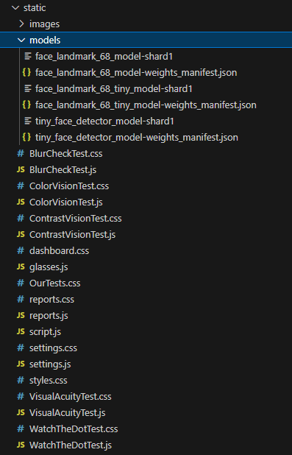

**Key Components:**

1. Face Detection Models
   * Model files
   * Weight configurations
   * Detection algorithms
2. Test Implementation Files
   * Visual acuity test logic
   * Color vision test implementation
   * Contrast vision calculations
   * Blur check algorithms
   * Watch dot test processing

4.4 Templates Directory

Contains HTML templates for all pages.

**Organization:**

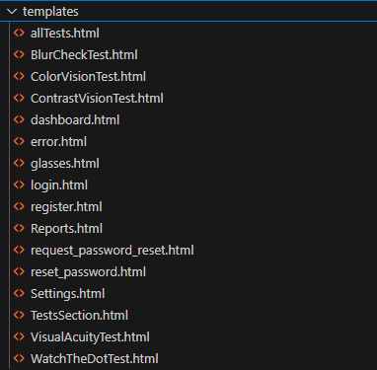

**Template Components:**

1. Authentication Pages
   * Login interface
   * Registration form
   * Password reset
2. Test Interfaces
   * Test-specific layouts
   * Interactive elements
   * Result displays

4.5 JavaScript Files Review

4.5.1 VisualAcuityTest.js

Purpose: Implements progressive visual acuity testing with dynamic distance calibration.

Core Functions:

startTest()

• Input: None

• Output: Initializes test environment and settings

• Purpose: Sets up initial test configuration and camera calibration

handleEyeSwitch()

• Input: Current eye state

• Output: Updated test configuration

• Purpose: Manages transition between eyes and resets test parameters

calculateDistance()

• Input: Face detection data

• Output: Distance in centimeters

• Purpose: Computes user distance from screen using facial recognition

Core Features:

- Separate eye tracking and scoring

- Real-time distance monitoring

- Adaptive difficulty progression

- Result submission and validation

4.5.2 ColorVisionTest.js

Purpose: Implements Ishihara-style color vision assessment.

Core Functions:

loadNextPattern()

• Input: Current test index

• Output: Updates display with new pattern

• Purpose: Controls test progression and pattern presentation

validateResponse()

• Input: User selection, correct pattern value

• Output: Score update and feedback

• Purpose: Evaluates user responses and updates test progress

Core Features:

- Dynamic pattern generation

- Multiple choice validation

- Score tracking per pattern

- Comprehensive result compilation

4.5.3 ContrastVisionTest.js

Purpose: Manages contrast sensitivity assessment through incremental testing.

Core Functions:

generatePattern()

• Input: Current contrast level

• Output: Visual contrast pattern

• Purpose: Creates test patterns with specific contrast ratios

processResponse()

• Input: User selection (left/right)

• Output: Score update and progression

• Purpose: Validates responses and adjusts difficulty

Core Features:

- Contrast level management

- Side-based pattern generation

- Progressive difficulty scaling

- Error tracking and feedback

4.5.4 BlurCheckTest.js

Purpose: Implements blur detection through number recognition.

Core Functions:

displayNumber()

• Input: Current blur level

• Output: Blurred number display

• Purpose: Generates and displays test numbers with controlled blur

validateInput()

• Input: User input number

• Output: Validation result

• Purpose: Checks user response against displayed number

Core Features:

- Random number generation

- Progressive blur application

- Input validation

- Score calculation

4.5.5 WatchTheDotTest.js

Purpose: Implements Amsler grid test for central vision assessment.

Core Functions:

createGrid()

• Input: Grid parameters

• Output: SVG grid with central dot

• Purpose: Generates test grid for vision assessment

processGridResponse()

• Input: User feedback on pattern regularity

• Output: Test result update

• Purpose: Records and evaluates user perception of grid

Core Features:

- SVG grid generation

- Eye-specific testing

- Pattern distortion detection

- Result compilation

Common Features Across All Tests:

- Session management

- Error handling

- Progress tracking

- Result storage and submission

- User interaction validation

- Responsive design adaptation

- Browser compatibility checks

- Performance optimization

5. Deployment

5.1 Overview

OptiVision is deployed using Vercel, with database services provided by Railway. The deployment is directly linked to the GitHub repository, enabling automatic updates whenever changes are pushed to the main branch. The setup includes both frontend static files and Flask backend services.

5.2 Vercel Configuration

**vercel.json**

{

    "builds": [

        {

            "src": "app.py",

            "use": "@vercel/python"

        }

    ],

    "routes": [

        {

            "src": "/(.*)",

            "dest": "app.py"

        }

    ]

}

**Environment Variables**

Essential environment variables that need to be configured:

* MYSQL_HOST: Database host
* MYSQL_USER: Database username
* MYSQL_PASSWORD: Database password
* MYSQL_DATABASE: Database name
* MYSQL_PORT: Database port
* SECRET_KEY: Application secret key

5.3 Deployment Process

1. Repository Setup

# Initialize git repository

git init

git add .

git commit -m "Initial commit"

git remote add origin https://github.com/TameerAmer/Capstone-Project

git push -u origin main

**2. Vercel Deployment Steps**

1. Connect GitHub repository to Vercel
2. Configure build settings:
   * Framework Preset: Other
   * Build Command: pip install -r requirements.txt
   * Output Directory: ./
   * Install Command: python -m pip install --upgrade pip

**3. Database Setup**

1. Create Railway MySQL instance
2. Configure database credentials
3. Set up environment variables
4. Initialize database tables

6. Technical Documentation

6.1 Database Relationship Diagram

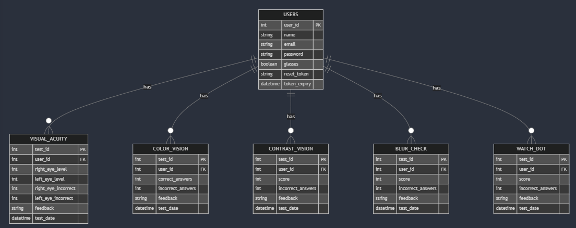

6.2 API Documentation

**Authentication Endpoints**

**POST /login**

Authenticates a user and returns a session token.

Request:

{

    "email": "string",

    "password": "string"

}

Response:

{

    "success": true,

    "user_id": "integer",

    "user_name": "string"

}

**POST /register**

Creates a new user account.

Request:

{

    "name": "string",

    "email": "string",

    "password": "string"

}

**Test Result Endpoints**

**POST /Visual_Acuity_save_results**

Saves visual acuity test results.

Request:

{

    "rightEyeLevel": "integer",

    "leftEyeLevel": "integer",

    "rightEyeIncorrect": "integer",

    "leftEyeIncorrect": "integer",

    "feedBack": "string"

}

**POST /all other test_save_results**

Request:

{

    "score": "integer",

    "incorrectanswers": "integer",

    "feedBack": "string"

}

Response for all endpoints:

{

    "success": boolean,

    "message": "string"

}

6.3 Error Handling

6.3.1 Database Errors

def handle_database_error(operation):

    """

    Generic database error handler

    """

    try:

        # Database operation

        connection = get_connection()

        if not connection:

            log_error("Database connection failed")

            return {

                "success": False,

                "error": "Connection error",

                "code": "DB001"

            }

    except mysql.connector.Error as e:

        log_error(f"MySQL Error: {str(e)}")

        return {

            "success": False,

            "error": "Database error",

            "code": f"DB{e.errno}"

        }

    except Exception as e:

        log_error(f"Unexpected error: {str(e)}")

        return {

            "success": False,

            "error": "Server error",

            "code": "SRV001"

        }

6.3.2 Test Processing Errors

def handle_test_error(test_type, error):

    """

    Handle test-specific errors

    """

    error_codes = {

        "visual_acuity": "VA",

        "color_vision": "CV",

        "contrast_vision": "CN",

        "blur_check": "BC",

        "watch_dot": "WD"

    }

    error_msg = f"Error in {test_type}: {str(error)}"

    error_code = f"{error_codes.get(test_type, 'TEST')}001"

    log_error(error_msg)

    return {

        "success": False,

        "error": error_msg,

        "code": error_code

    }

6.4 Troubleshooting Guide

6.4.1 Authentication Issues

1. Login Failures

Problem: Unable to log in

Solutions:

* + Verify email and password
  + Check for caps lock
  + Clear browser cache
  + Reset password if necessary

1. Session Issues

Problem: Being logged out unexpectedly

Solutions:

* + Check session timeout settings
  + Clear browser cookies
  + Verify browser compatibility

6.4.2 Test Execution Issues

1. Webcam Problems

Problem: Webcam not working

Solutions:

* + Check browser permissions
  + Verify webcam connection
  + Ensure proper lighting
  + Try different browser

1. Distance Calibration

Problem: Unable to calibrate distance

Solutions:

* + Ensure face is fully visible
  + Check lighting conditions
  + Adjust webcam position
  + Verify face detection model loaded

6.4.3 Database Connection Issues

1. Connection Timeouts

Problem: Database connection fails

Solutions:

* + Verify database credentials
  + Check network connectivity
  + Confirm port access
  + Review connection pool settings

1. Query Errors

Problem: Database operations fail

Solutions:

* + Check SQL syntax
  + Verify data types
  + Review transaction handling
  + Check for deadlocks

6.4.4 Performance Issues

1. Slow Response Times

Problem: System responds slowly

Solutions:

* + Check server load
  + Review database queries
  + Monitor memory usage
  + Optimize test processing

1. Resource Usage

Problem: High resource consumption

Solutions:

* + Monitor memory leaks
  + Optimize database queries
  + Review file cleanup
  + Check face detection performance